DYR Exercise #4a OXPET
(Hebrews 5:13-14)
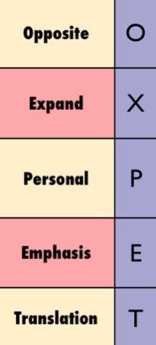
Paul J. Bucknell

I long for Thy salvation, O LORD, and Thy law is my delight. (Psalm 119:174)

- Review OXPET’s five ways to study. Write down in your own words what each word stands for.
O:
X:
P:
X:
T:

Apply Oxpet’s rules to enhance Psalm 119:174’s meaning and application.

Review your above conclusions and write your answers below.

- How did OXPET help you?
- What frustrations did you find, if any?

