DYR Exercise #3 Meeting With God (Exodus 33:7-11)
Paul J. Bucknell

Study Questions (DYR #5)
After carefully reading Exodus 33:7-11 and observing its context, answer the following questions to the best of your ability.

- What makes a meeting with God so important? Your answer should reflect some thoughts from Exodus 33:7-11.
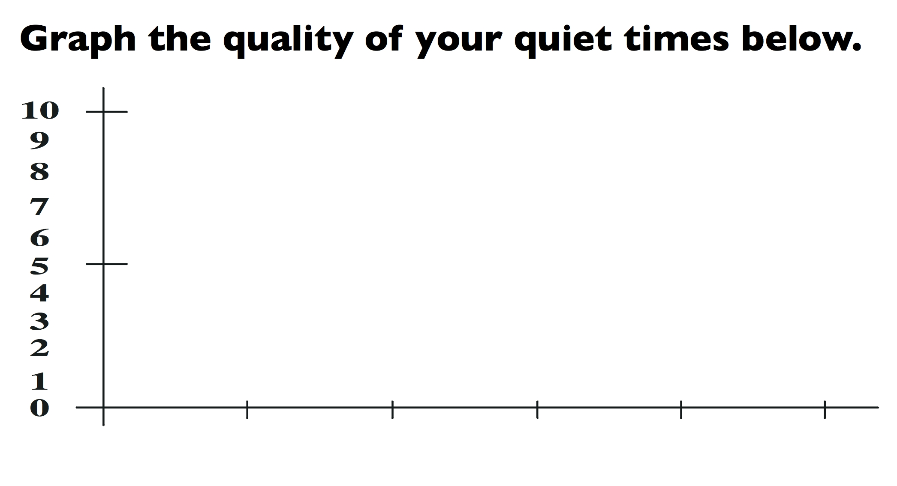
- Graph the quality of your personal devotions since you became a Christian? What observations do you have? (10 is excellent; 0 is null. On bottom left put the year you came to know the Lord and on the right bottom this year.)

- What was your relationship like with your earthly father? Did you have significant conversations? How has this shaped or influenced your relationship with your Heavenly Father?
- What would you want from daily meetings with God? Name at least 3 things.

DYR Exercise #3 A Quiet Time
Paul J. Bucknell

Have a quiet time with the Lord in His Word!
- Hope: Tell Him what you want from this time together.
- Read: Quickly pick a passage and carefully read.
- Listen: Think about what He wants to teach you. What did He “say” to you? Try to stay with the passage until something stands out to you.
- How should His Word impact your life?
- Will you obey by making the required changes? How and when?

