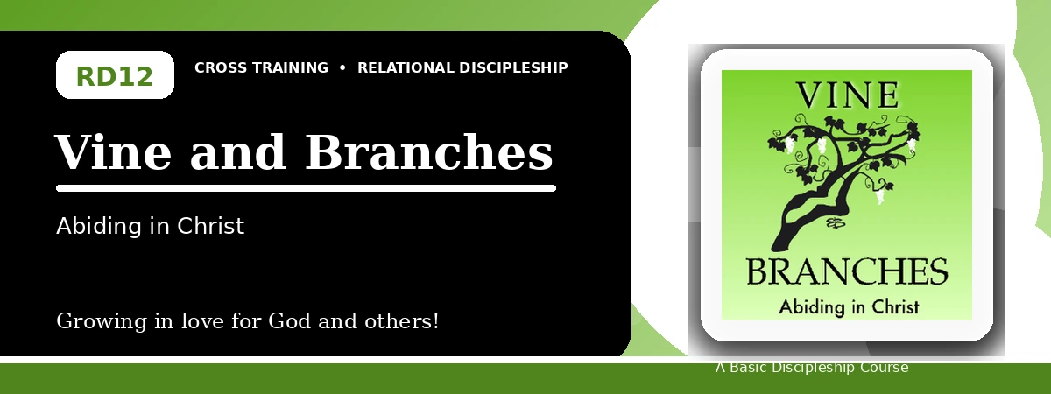
Relational Discipleship: Cross Training
Student Quiz
Abiding in Christ for Fruitfulness and Joyful Dependence
Instructions: Answer the following questions from the lesson. Use Scripture references where helpful. For short answers, write clearly and briefly.

1. [Multiple Choice] What relationship picture guides the final lesson?
A. Vine - Branches
B. Judge - Guilty
C. Father - Child
D. Master - Servant
________________________________________________________________________________________
2. [Short Answer] Who is the gardener in John 15?
________________________________________________________________________________________
________________________________________________________________________________________
3. [Multiple Choice] According to John 15:5, what can branches do apart from Christ?
A. Nothing
B. Everything
C. More fruit
D. Greater works without Him
________________________________________________________________________________________
4. [Fill-in] John 15:4 says, "Abide in Me, and I in _____."
________________________________________________________________________________________
5. [Scripture Reflection] How should God's pruning encourage rather than discourage a believer?
________________________________________________________________________________________
________________________________________________________________________________________
6. [Short Answer] Name two parts of abiding in Christ.
________________________________________________________________________________________
________________________________________________________________________________________
7. [Multiple Choice] What is the goal of pruning?
A. More fruit
B. Less dependence
C. Independence from Christ
D. Avoiding hardship forever
________________________________________________________________________________________
8. [Application] Identify one obstacle that keeps you from abiding fully in Christ.
________________________________________________________________________________________
________________________________________________________________________________________
9. [Memory Verse] What is the memory verse?
________________________________________________________________________________________
10. [Short Answer] How does discipline differ from pruning in the lesson?
________________________________________________________________________________________
________________________________________________________________________________________
11. [Discussion] Why is dependence difficult for believers who value control?
________________________________________________________________________________________
________________________________________________________________________________________
12. [Application] What daily practice will help you remain close to Christ this week?
________________________________________________________________________________________
________________________________________________________________________________________
Optional reflection: What one truth from this lesson should shape your relationships this week?
________________________________________________________________________________________
________________________________________________________________________________________

