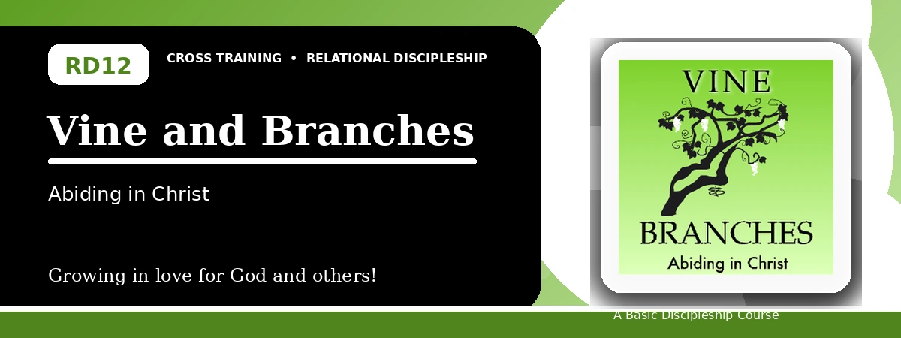
Relational Discipleship: Cross Training
Quiz Answer Key
Abiding in Christ for Fruitfulness and Joyful Dependence
Instructor Use: This answer key gives concise model answers. Accept equivalent answers that clearly reflect the lesson content and Scripture emphasis.

1. [Multiple Choice] What relationship picture guides the final lesson?
A. Vine - Branches
B. Judge - Guilty
C. Father - Child
D. Master - Servant
Answer: A
2. [Short Answer] Who is the gardener in John 15?
Answer: God the Father.
3. [Multiple Choice] According to John 15:5, what can branches do apart from Christ?
A. Nothing
B. Everything
C. More fruit
D. Greater works without Him
Answer: A
4. [Fill-in] John 15:4 says, "Abide in Me, and I in _____."
Answer: you
5. [Scripture Reflection] How should God's pruning encourage rather than discourage a believer?
Answer: It shows the Father is actively making fruitful branches more fruitful.
6. [Short Answer] Name two parts of abiding in Christ.
Answer: Surrender, obedience, receiving His Word, prayer, yielding, dependence, and staying close to Him.
7. [Multiple Choice] What is the goal of pruning?
A. More fruit
B. Less dependence
C. Independence from Christ
D. Avoiding hardship forever
Answer: A
8. [Application] Identify one obstacle that keeps you from abiding fully in Christ.
Answer: Answers will vary; should name a specific obstacle.
9. [Memory Verse] What is the memory verse?
Answer: John 15:4-5.
10. [Short Answer] How does discipline differ from pruning in the lesson?
Answer: Discipline brings disobedient believers back to the Lord; pruning makes abiding believers more fruitful through difficulty.
11. [Discussion] Why is dependence difficult for believers who value control?
Answer: Because abiding requires surrender, trust, obedience, and receiving life from Christ rather than self-sufficiency.
12. [Application] What daily practice will help you remain close to Christ this week?
Answer: Answers may include Scripture, prayer, journaling, confession, obedience, thanksgiving, or service.

Suggested Grading Emphasis
- God carefully oversees our lives and disciplines us when we do not obey Him.
- We are pruned to produce more fruit, and we need to trust Him during the difficult process.
- When we stay close to Christ through obedience, Christ produces much fruit in us.

