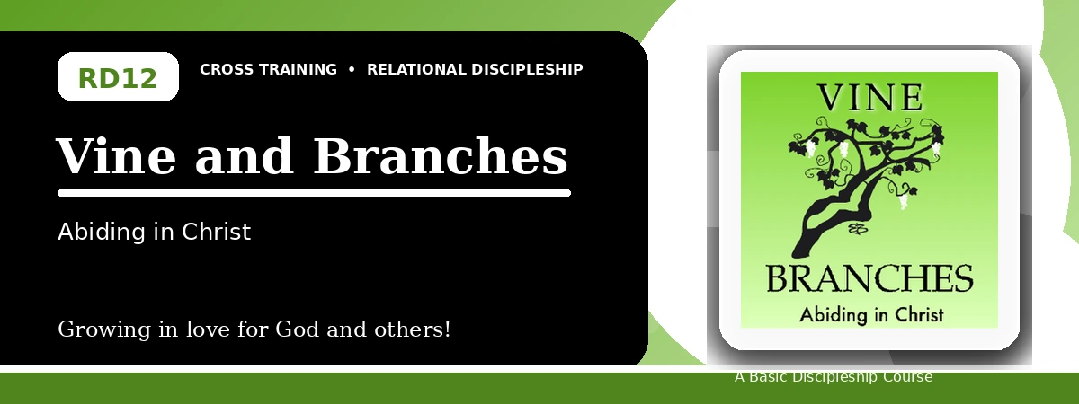
Relational Discipleship: Cross Training
Participant Notes Handout
Abiding in Christ for Fruitfulness and Joyful Dependence
One-line summary: Because Christ is the Vine, believers bear lasting fruit only by abiding closely in Him.
Paragraph summary: The Vine-Branches lesson gives one of the clearest pictures of the abundant Christian life. The Father is the gardener who lovingly cares, disciplines, and prunes. Christ is the true Vine, and believers are branches who can do nothing apart from Him. Fruitfulness comes from abiding: surrendering the will, receiving His Word, depending on Him in prayer, and trusting His pruning process.

Basic Lesson Information
Item | Content
Main relationship picture | Vine - Branches
Theme | Dependence and Fruitfulness
Character emphasis | Dependence, yielding, obedience, fruitfulness
Memory verse | John 15:4-5

Lesson Goals
- God our Father is the gardener: God attentively cares for His people
- Christ is the vine: God builds up one's life to produce more fruits
- We are the branches: Remaining close to the vine produces fruit

God Is the Gardener
Key Scripture: John 15:1-2; Hebrews 12:6-7
Main ideas:
- The Father carefully cares for the vine.
- He deals with branches differently according to their need.
- God disciplines His children in love to bring them out of sin.
Think about: What difficulty might be God's loving discipline or care?
Notes:
________________________________________________________________________________________
________________________________________________________________________________________
________________________________________________________________________________________
________________________________________________________________________________________
________________________________________________________________________________________

Producing More Fruits
Key Scripture: John 15:16
Main ideas:
- God's goal is lasting fruit.
- Pruning removes what is diseased, dead, wild, or draining.
- Pruning can come through difficulty so the fruitful become more fruitful.
Think about: What might be draining your time or energy from God's main purpose?
Notes:
________________________________________________________________________________________
________________________________________________________________________________________
________________________________________________________________________________________
________________________________________________________________________________________
________________________________________________________________________________________

Staying Close to the Vine
Key Scripture: John 15:5, 7, 16
Main ideas:
- To abide is to surrender, yield, obey, and receive all Christ has for us.
- Apart from Christ we can do nothing.
- Abiding joins prayer, God's Word, obedience, and lasting fruit.
Think about: What helps you remain close to Christ each day?
Notes:
________________________________________________________________________________________
________________________________________________________________________________________
________________________________________________________________________________________
________________________________________________________________________________________
________________________________________________________________________________________

Take-Home Practice
- Memorize John 15:4-5.
- Keep a journal of your spiritual walk with God.
- Note things that keep you from abiding fully in Christ.
- Ask God to remove obstacles one by one.
- Thank Him regularly for choosing you to bear fruit.

Personal Commitment
This week I will:
________________________________________________________________________________________
________________________________________________________________________________________
________________________________________________________________________________________
________________________________________________________________________________________

