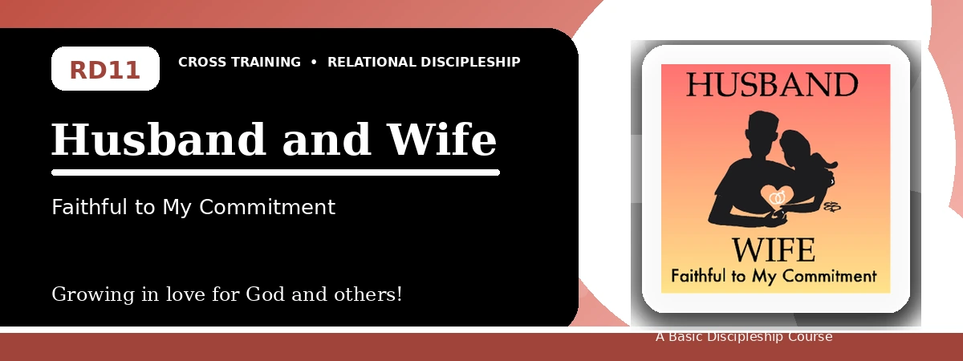
Relational Discipleship: Cross Training
Student Quiz
Honoring Covenant, Authority, Trust, and Oneness
Instructions: Answer the following questions from the lesson. Use Scripture references where helpful. For short answers, write clearly and briefly.

1. [Multiple Choice] What relationship picture shapes Lesson 11?
A. Husband - Wife
B. Shepherd - Lamb
C. King - Kingdom
D. Priest - People
________________________________________________________________________________________
2. [Short Answer] What mystery does Ephesians 5 connect with marriage?
________________________________________________________________________________________
________________________________________________________________________________________
3. [Multiple Choice] What is one goal of the lesson?
A. Appreciate and respect authorities
B. Reject all commitment
C. Avoid forgiveness
D. Remove all obligations
________________________________________________________________________________________
4. [Fill-in] Colossians 3 says beyond forgiveness and bearing with one another, put on _____.
________________________________________________________________________________________
5. [Scripture Reflection] How does Christ's sacrificial love shape marriage and church life?
________________________________________________________________________________________
________________________________________________________________________________________
6. [Short Answer] Name two ways to strengthen oneness.
________________________________________________________________________________________
________________________________________________________________________________________
7. [Multiple Choice] According to Matthew 19:6, what God has joined together, man should not _____.
A. Separate
B. Honor
C. Bless
D. Remember
________________________________________________________________________________________
8. [Application] What words, actions, or attitudes need to change in one relationship?
________________________________________________________________________________________
________________________________________________________________________________________
9. [Memory Verse] What is the memory verse?
________________________________________________________________________________________
10. [Short Answer] Why is authority difficult for many people?
________________________________________________________________________________________
________________________________________________________________________________________
11. [Discussion] How can trust in Christ help someone respond rightly to imperfect human authority?
________________________________________________________________________________________
________________________________________________________________________________________
12. [Application] Write one step to affirm your oneness with the Lord or spouse.
________________________________________________________________________________________
________________________________________________________________________________________
Optional reflection: What one truth from this lesson should shape your relationships this week?
________________________________________________________________________________________
________________________________________________________________________________________

