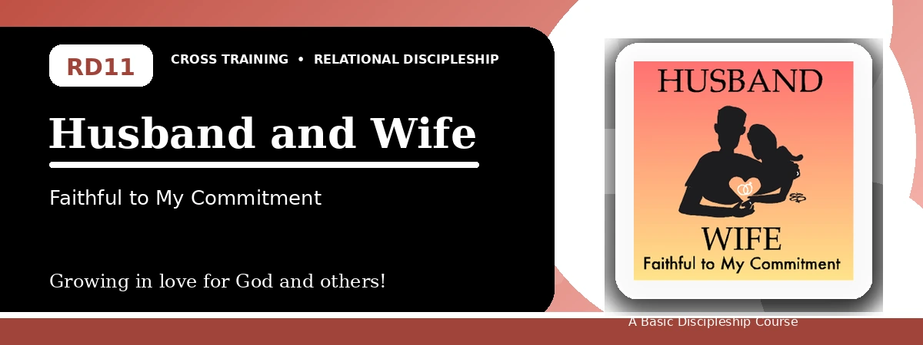
Relational Discipleship: Cross Training
Quiz Answer Key
Honoring Covenant, Authority, Trust, and Oneness
Instructor Use: This answer key gives concise model answers. Accept equivalent answers that clearly reflect the lesson content and Scripture emphasis.

1. [Multiple Choice] What relationship picture shapes Lesson 11?
A. Husband - Wife
B. Shepherd - Lamb
C. King - Kingdom
D. Priest - People
Answer: A
2. [Short Answer] What mystery does Ephesians 5 connect with marriage?
Answer: The relationship between Christ and the church.
3. [Multiple Choice] What is one goal of the lesson?
A. Appreciate and respect authorities
B. Reject all commitment
C. Avoid forgiveness
D. Remove all obligations
Answer: A
4. [Fill-in] Colossians 3 says beyond forgiveness and bearing with one another, put on _____.
Answer: love
5. [Scripture Reflection] How does Christ's sacrificial love shape marriage and church life?
Answer: It calls for faithful, self-giving love, trust, respect, forgiveness, and commitment.
6. [Short Answer] Name two ways to strengthen oneness.
Answer: Forgiveness, kindness, purity, faithful words, loving actions, respect, and practical care.
7. [Multiple Choice] According to Matthew 19:6, what God has joined together, man should not _____.
A. Separate
B. Honor
C. Bless
D. Remember
Answer: A
8. [Application] What words, actions, or attitudes need to change in one relationship?
Answer: Answers will vary; should identify a concrete change.
9. [Memory Verse] What is the memory verse?
Answer: Colossians 3:13-14.
10. [Short Answer] Why is authority difficult for many people?
Answer: Because pride, independence, disappointment, and modern culture resist submission and commitment.
11. [Discussion] How can trust in Christ help someone respond rightly to imperfect human authority?
Answer: By remembering Christ's lordship, seeking God's wisdom, obeying when appropriate, and refusing sinful responses.
12. [Application] Write one step to affirm your oneness with the Lord or spouse.
Answer: Answers may include confession, forgiveness, prayer, kindness, purity, time together, or renewed commitment.

Suggested Grading Emphasis
- Authorities are God-ordained, and I will accept and respect them.
- I will obey those in authority over me without grumbling when appropriate before God.
- I affirm oneness with my spouse by doing things that build up our relationship.

