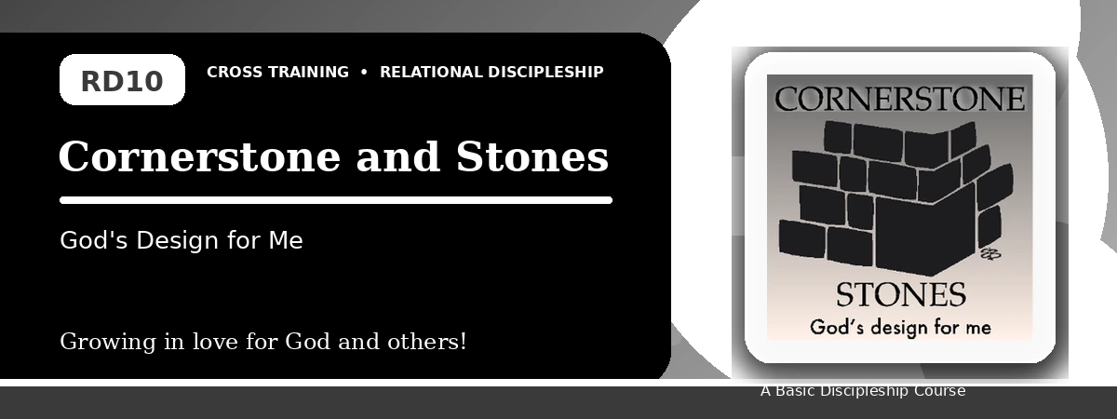
Relational Discipleship: Cross Training
Student Quiz
Finding Our Place in God's Design and Building Together
Instructions: Answer the following questions from the lesson. Use Scripture references where helpful. For short answers, write clearly and briefly.

1. [Multiple Choice] What is the lesson's main relationship picture?
A. Cornerstone - Stones
B. Father - Child
C. Redeemer - Chosen
D. Master - Servant
________________________________________________________________________________________
2. [Short Answer] Who is the cornerstone of God's spiritual house?
________________________________________________________________________________________
________________________________________________________________________________________
3. [Multiple Choice] What does 1 Peter 2:5 call believers?
A. Living stones
B. Lost sheep only
C. Empty vessels
D. Wandering tents
________________________________________________________________________________________
4. [Fill-in] 2 Corinthians 6:16 says, "We are the temple of the _____ God."
________________________________________________________________________________________
5. [Scripture Reflection] How should knowing Christ is the foundation affect our choices?
________________________________________________________________________________________
________________________________________________________________________________________
6. [Short Answer] Name two distractions that harm teamwork.
________________________________________________________________________________________
________________________________________________________________________________________
7. [Multiple Choice] What is Project Reconciliation about?
A. Improving a relationship with a fellow Christian
B. Winning an argument
C. Avoiding church life
D. Building alone
________________________________________________________________________________________
8. [Application] Name one believer you need to value or work with better.
________________________________________________________________________________________
________________________________________________________________________________________
9. [Memory Verse] What is the memory verse?
________________________________________________________________________________________
10. [Short Answer] Why is a stone image helpful for teamwork?
________________________________________________________________________________________
________________________________________________________________________________________
11. [Discussion] How do pride and comparison weaken the church?
________________________________________________________________________________________
________________________________________________________________________________________
12. [Application] What step can you take toward reconciliation?
________________________________________________________________________________________
________________________________________________________________________________________
Optional reflection: What one truth from this lesson should shape your relationships this week?
________________________________________________________________________________________
________________________________________________________________________________________

