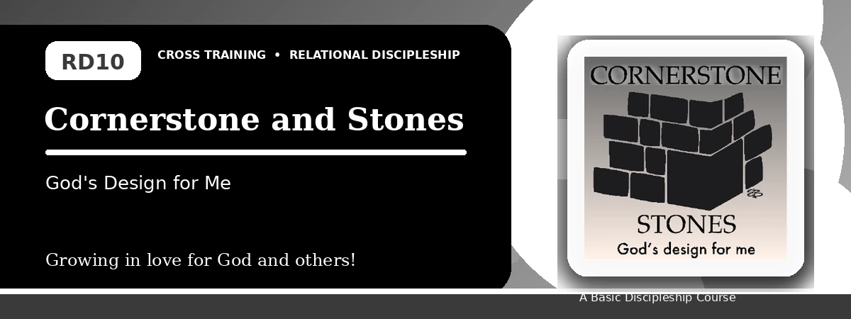
Relational Discipleship: Cross Training
Quiz Answer Key
Finding Our Place in God's Design and Building Together
Instructor Use: This answer key gives concise model answers. Accept equivalent answers that clearly reflect the lesson content and Scripture emphasis.

1. [Multiple Choice] What is the lesson's main relationship picture?
A. Cornerstone - Stones
B. Father - Child
C. Redeemer - Chosen
D. Master - Servant
Answer: A
2. [Short Answer] Who is the cornerstone of God's spiritual house?
Answer: Jesus Christ.
3. [Multiple Choice] What does 1 Peter 2:5 call believers?
A. Living stones
B. Lost sheep only
C. Empty vessels
D. Wandering tents
Answer: A
4. [Fill-in] 2 Corinthians 6:16 says, "We are the temple of the _____ God."
Answer: living
5. [Scripture Reflection] How should knowing Christ is the foundation affect our choices?
Answer: It should make us build carefully, please Him, and center effectiveness on Christ.
6. [Short Answer] Name two distractions that harm teamwork.
Answer: Pride, jealousy, envy, criticism, comparison, or self-image.
7. [Multiple Choice] What is Project Reconciliation about?
A. Improving a relationship with a fellow Christian
B. Winning an argument
C. Avoiding church life
D. Building alone
Answer: A
8. [Application] Name one believer you need to value or work with better.
Answer: Answers will vary; should identify a real relationship.
9. [Memory Verse] What is the memory verse?
Answer: 2 Corinthians 6:16.
10. [Short Answer] Why is a stone image helpful for teamwork?
Answer: Because stones are designed to fit together and form one strong structure.
11. [Discussion] How do pride and comparison weaken the church?
Answer: They shift focus from Christ, lower love, and break teamwork among believers.
12. [Application] What step can you take toward reconciliation?
Answer: Pray, confess, apologize, listen, encourage, serve, or initiate a humble conversation.

Suggested Grading Emphasis
- I need to fully accept the way God made me and placed me in life.
- All my decisions must please the Lord.
- I must appreciate the uniqueness of my brothers and sisters.

