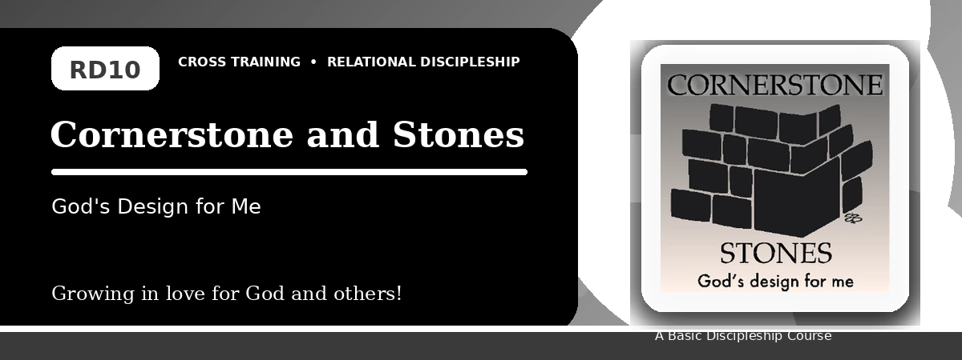
Relational Discipleship: Cross Training
Participant Notes Handout
Finding Our Place in God's Design and Building Together
One-line summary: Because Christ is the Cornerstone, believers embrace God's design and work together as living stones.
Paragraph summary: The Cornerstone-Stones lesson highlights Christ as the foundation and chief cornerstone of God's spiritual house. Believers are living stones placed by God, not isolated blocks. They embrace His design for their lives, focus on Christ for effectiveness, reject pride and jealousy, and lovingly work with other believers as part of God's temple.

Basic Lesson Information
Item | Content
Main relationship picture | Cornerstone - Stones
Theme | Dependence and Coordination
Character emphasis | Dependence, teamwork, love, coordination
Memory verse | 2 Corinthians 6:16

Lesson Goals
- Christ embraced God's design: Embrace God's design for my life
- Christ is our Cornerstone: Focus on Jesus for effectiveness
- Christians are living stones: Lovingly work with others

Embrace God's Design
Key Scripture: Isaiah 28:16; 1 Peter 2:4-5
Main ideas:
- Christ embraced His appointed place as cornerstone.
- God has a design for each believer's life and placement.
- Accepting God's design frees us from comparison and complaint.
Think about: Where do you need to accept God's design for your life?
Notes:
________________________________________________________________________________________
________________________________________________________________________________________
________________________________________________________________________________________
________________________________________________________________________________________
________________________________________________________________________________________

Focus on Jesus
Key Scripture: Ephesians 2:19-20; 1 Corinthians 3:10-13
Main ideas:
- Christ is the foundation that makes spiritual building effective.
- Each person must be careful how he builds.
- Pride, jealousy, envy, and criticism distract from Christ-centered building.
Think about: What distraction pulls your attention away from Christ?
Notes:
________________________________________________________________________________________
________________________________________________________________________________________
________________________________________________________________________________________
________________________________________________________________________________________
________________________________________________________________________________________

Teamwork and Love
Key Scripture: 1 Peter 2:5; John 13:34
Main ideas:
- Believers are living stones built into a spiritual house.
- Each Christian is important and valuable in God's design.
- Love and commitment hold the stones together in teamwork.
Think about: Which fellow believer do you need to value more deeply?
Notes:
________________________________________________________________________________________
________________________________________________________________________________________
________________________________________________________________________________________
________________________________________________________________________________________
________________________________________________________________________________________

Take-Home Practice
- Memorize 2 Corinthians 6:16.
- Begin Project Reconciliation with one fellow Christian where the relationship needs improvement.
- Practice teamwork by identifying how you fit with others in God's spiritual house.

Personal Commitment
This week I will:
________________________________________________________________________________________
________________________________________________________________________________________
________________________________________________________________________________________
________________________________________________________________________________________

