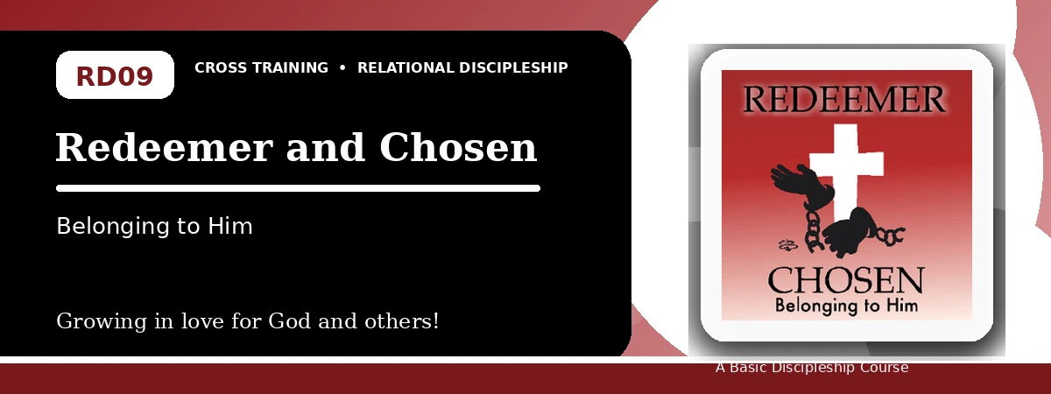
Relational Discipleship: Cross Training
Quiz Answer Key
Belonging to God and Showing Kindness Because He Redeemed Us
Instructor Use: This answer key gives concise model answers. Accept equivalent answers that clearly reflect the lesson content and Scripture emphasis.

1. [Multiple Choice] What is the relationship picture in Lesson 9?
A. Redeemer - Chosen
B. Teacher - Disciple
C. Judge - Guilty
D. Vine - Branches
Answer: A
2. [Short Answer] What did God pay to redeem His people?
Answer: The precious blood of Christ.
3. [Multiple Choice] According to John 15:16, who chose whom?
A. Christ chose His people
B. The disciples chose Christ first
C. Rome chose the church
D. People choose grace by deserving it
Answer: A
4. [Fill-in] Colossians 1 says we have redemption, the forgiveness of _____.
Answer: sins
5. [Scripture Reflection] How does 1 Peter 1:18-19 deepen gratitude?
Answer: It shows that we were redeemed at the priceless cost of Christ's blood, not with silver or gold.
6. [Short Answer] Name the three main responses in the lesson goals.
Answer: Develop gratitude, endure suffering for others, and value one another.
7. [Multiple Choice] What is one recommended step for dealing with difficult people?
A. Pray for your enemies
B. Seek revenge
C. Withdraw all kindness
D. Pretend sin does not matter
Answer: A
8. [Application] Name one difficult person or situation where you need to show kindness.
Answer: Answers will vary; should identify a real situation.
9. [Memory Verse] What is the memory verse?
Answer: Colossians 1:13-14.
10. [Short Answer] Why does belonging to God change our response to suffering?
Answer: Because our identity, future, and value are secured by the Redeemer, so we can endure faithfully.
11. [Discussion] Why do people struggle to feel wanted, and how does redemption answer that?
Answer: Answers may mention rejection, shame, or abandonment; redemption shows God's costly love and ownership.
12. [Application] What practice can deepen gratitude this week?
Answer: Meditation on grace, prayer, journaling, praise, or remembering Christ's redemption.

Suggested Grading Emphasis
- I will always be grateful to the Lord for His choice of me.
- I will joyfully carry out God's will no matter how difficult.
- I will be kind to others even when it is hard, as God has been gracious to me.

