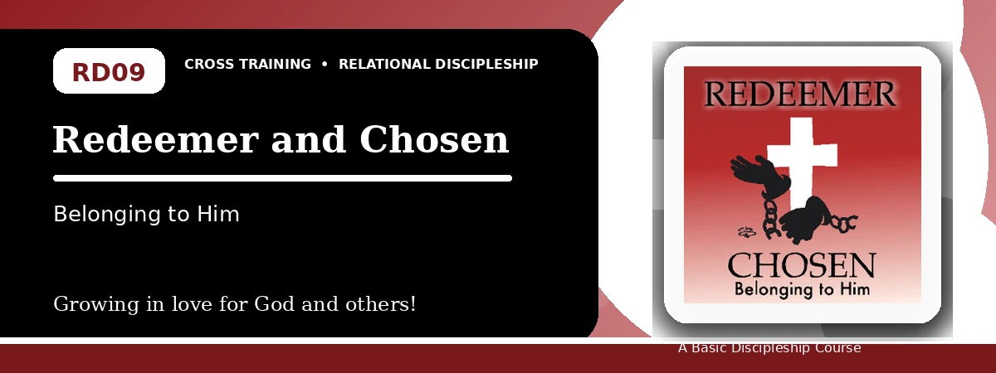
Relational Discipleship: Cross Training
Participant Notes Handout
Belonging to God and Showing Kindness Because He Redeemed Us
One-line summary: Because God chose and redeemed us at great cost, we live with gratitude, endurance, and kindness toward others.
Paragraph summary: The Redeemer-Chosen lesson shows that redemption is not a cold business term but a deeply personal picture of God's love. God chose His people by grace and bought them with the precious blood of Christ. Believers therefore belong to Him, deepen gratitude, endure hardship faithfully, and treat difficult people with God's kindness because they themselves have received undeserved grace.

Basic Lesson Information
Item | Content
Main relationship picture | Redeemer - Chosen
Theme | Belonging and Choice
Character emphasis | Gratitude, endurance, kindness, devotion
Memory verse | Colossians 1:13-14

Lesson Goals
- God chose us: Develop a deeper heart of gratitude
- God bought us: Endure suffering for others
- We belong to Him: Value one another

God Chose Us
Key Scripture: Ephesians 1:4; Romans 9:23; John 15:16
Main ideas:
- God's choice is undeserved grace.
- We did not choose Christ first; He chose and appointed us.
- His grace should quiet our hearts and deepen gratitude.
Think about: How can you give thanks for God's choice of you?
Notes:
________________________________________________________________________________________
________________________________________________________________________________________
________________________________________________________________________________________
________________________________________________________________________________________
________________________________________________________________________________________

God Bought Us
Key Scripture: Isaiah 53:5-6; 1 Peter 1:18-19
Main ideas:
- The Lord followed His choice by saving us through Christ.
- Redemption was purchased not with silver or gold but with Christ's precious blood.
- The high price of love calls for wholehearted devotion.
Think about: How does Christ's purchase price affect your priorities?
Notes:
________________________________________________________________________________________
________________________________________________________________________________________
________________________________________________________________________________________
________________________________________________________________________________________
________________________________________________________________________________________

We Belong to Him
Key Scripture: Hebrews 11:25; 1 Peter 2:20; Romans 12:17-21
Main ideas:
- Belonging to God changes how we respond to difficult people and suffering.
- We can choose ill-treatment with God's people over passing pleasures of sin.
- God calls us to kindness, prayer for enemies, wisdom, and perseverance.
Think about: Which difficult person or situation needs a grace-shaped response?
Notes:
________________________________________________________________________________________
________________________________________________________________________________________
________________________________________________________________________________________
________________________________________________________________________________________
________________________________________________________________________________________

Take-Home Practice
- Memorize Colossians 1:13-14.
- Set aside 15 minutes three times this week to meditate on belonging to God.
- List the hardest thing you had to do to be faithful to God.
- Identify three difficult people or situations and work through a biblical response.

Personal Commitment
This week I will:
________________________________________________________________________________________
________________________________________________________________________________________
________________________________________________________________________________________
________________________________________________________________________________________

