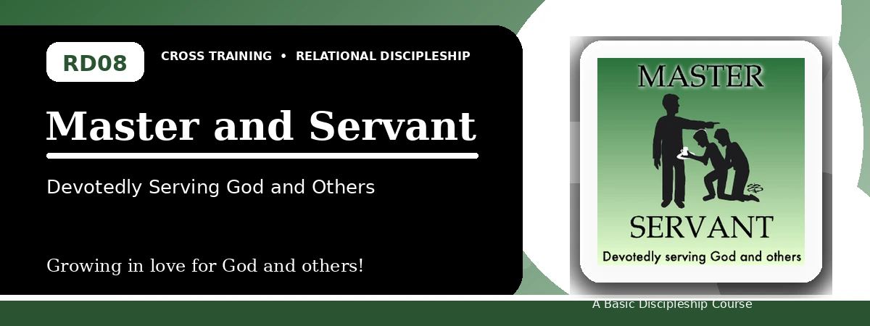
Relational Discipleship: Cross Training
Student Quiz
Serving God and Others with Faithful Availability
Instructions: Answer the following questions from the lesson. Use Scripture references where helpful. For short answers, write clearly and briefly.

1. [Multiple Choice] What relationship picture shapes Lesson 8?
A. Master - Servant
B. Bridegroom - Bride
C. Shepherd - Lamb
D. Cornerstone - Stones
________________________________________________________________________________________
2. [Short Answer] What did Jesus model by coming not to do His own will?
________________________________________________________________________________________
________________________________________________________________________________________
3. [Multiple Choice] According to Luke 16:13, how many masters can a servant serve?
A. One
B. Two equally
C. Many
D. None
________________________________________________________________________________________
4. [Fill-in] Philippians 2 says Christ took the form of a _____.
________________________________________________________________________________________
5. [Scripture Reflection] How does John 13:13-16 shape our understanding of humble service?
________________________________________________________________________________________
________________________________________________________________________________________
6. [Short Answer] Name the three lesson goals.
________________________________________________________________________________________
________________________________________________________________________________________
7. [Multiple Choice] What is one danger the lesson identifies?
A. Asserting our rights rather than serving
B. Serving others too humbly
C. Obeying Christ too much
D. Praying too often
________________________________________________________________________________________
8. [Application] List one practical need you can meet this week.
________________________________________________________________________________________
________________________________________________________________________________________
9. [Memory Verse] What is the memory verse?
________________________________________________________________________________________
10. [Short Answer] Why is stewardship included in a servant mindset?
________________________________________________________________________________________
________________________________________________________________________________________
11. [Discussion] What attitude makes serving others difficult?
________________________________________________________________________________________
________________________________________________________________________________________
12. [Application] How can you use money, knowledge, or talent to glorify God?
________________________________________________________________________________________
________________________________________________________________________________________
Optional reflection: What one truth from this lesson should shape your relationships this week?
________________________________________________________________________________________
________________________________________________________________________________________

