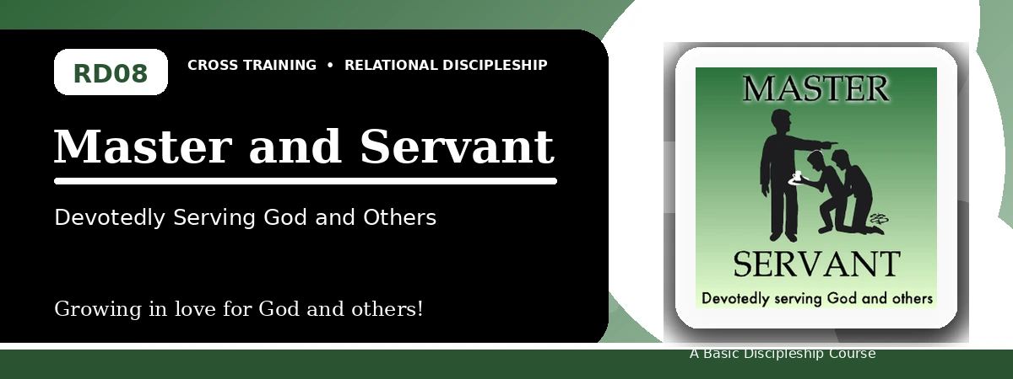
Relational Discipleship: Cross Training
Quiz Answer Key
Serving God and Others with Faithful Availability
Instructor Use: This answer key gives concise model answers. Accept equivalent answers that clearly reflect the lesson content and Scripture emphasis.

1. [Multiple Choice] What relationship picture shapes Lesson 8?
A. Master - Servant
B. Bridegroom - Bride
C. Shepherd - Lamb
D. Cornerstone - Stones
Answer: A
2. [Short Answer] What did Jesus model by coming not to do His own will?
Answer: He modeled full availability and obedience to the Father.
3. [Multiple Choice] According to Luke 16:13, how many masters can a servant serve?
A. One
B. Two equally
C. Many
D. None
Answer: A
4. [Fill-in] Philippians 2 says Christ took the form of a _____.
Answer: bond-servant or servant
5. [Scripture Reflection] How does John 13:13-16 shape our understanding of humble service?
Answer: Jesus, the Lord and Teacher, washed feet and called His disciples to serve one another humbly.
6. [Short Answer] Name the three lesson goals.
Answer: Be fully available to serve God, willingly obey Christ, and practically serve others.
7. [Multiple Choice] What is one danger the lesson identifies?
A. Asserting our rights rather than serving
B. Serving others too humbly
C. Obeying Christ too much
D. Praying too often
Answer: A
8. [Application] List one practical need you can meet this week.
Answer: Answers will vary; should name a concrete need and action.
9. [Memory Verse] What is the memory verse?
Answer: Philippians 2:5-7.
10. [Short Answer] Why is stewardship included in a servant mindset?
Answer: Because all we have belongs to the Lord and should be used for His glory.
11. [Discussion] What attitude makes serving others difficult?
Answer: Answers may mention pride, rights, selfishness, fear, laziness, or resentment.
12. [Application] How can you use money, knowledge, or talent to glorify God?
Answer: Answers will vary; should show stewardship for God's purposes.

Suggested Grading Emphasis
- Our availability: we selflessly serve the Father as Christ did.
- Our decisions: we regularly and readily obey Jesus.
- Our attitudes: we joyfully and faithfully serve others.

