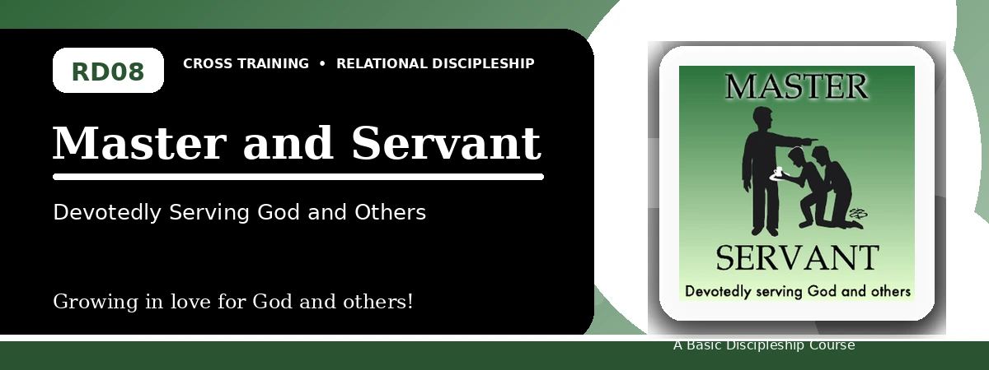
Relational Discipleship: Cross Training
Participant Notes Handout
Serving God and Others with Faithful Availability
One-line summary: Because Christ faithfully served the Father, believers willingly obey their Master and practically serve others.
Paragraph summary: The Master-Servant lesson challenges the desire to have no master and presents Christ as the faithful Servant who humbled Himself and obeyed the Father. Believers serve Christ as Master by choosing one Lord, rejecting sin's rule, and becoming fully available for God's will. This servant mindset becomes visible in practical care, humble leadership, stewardship, and joyful service to others.

Basic Lesson Information
Item | Content
Main relationship picture | Master - Servant
Theme | Faithful and Attentive
Character emphasis | Faithfulness, humility, attentiveness, service
Memory verse | Philippians 2:5-7

Lesson Goals
- Christ devotedly served the Father: Be fully available to serve God
- We serve Christ our Master: Willingly obey Christ
- We are to serve one another: Be committed to practically serve

Available to Serve God
Key Scripture: John 6:38; Philippians 2:5-7; Luke 22:42
Main ideas:
- Christ came not to do His own will but the Father's will.
- He humbled Himself and took the form of a servant.
- Availability means surrendering rights and responding rightly to tests.
Think about: Where is God testing your availability to serve?
Notes:
________________________________________________________________________________________
________________________________________________________________________________________
________________________________________________________________________________________
________________________________________________________________________________________
________________________________________________________________________________________

Willingly Obey Christ
Key Scripture: John 12:26; 2 Peter 2:19; Luke 16:13; Romans 6:11
Main ideas:
- Everyone serves someone.
- A believer must choose one Master rather than serve divided loyalties.
- In Christ, believers consider themselves dead to sin and alive to God.
Think about: What rival master tries to rule your choices?
Notes:
________________________________________________________________________________________
________________________________________________________________________________________
________________________________________________________________________________________
________________________________________________________________________________________
________________________________________________________________________________________

Practically Serving Others
Key Scripture: John 15:17; John 13:13-16; Luke 22:24-27; Matthew 25:22-23
Main ideas:
- Christ commands love and models humble service.
- Leadership in Christ's kingdom is characterized by service.
- Faithful service brings the Master's commendation.
Think about: What need can you meet with a servant mindset?
Notes:
________________________________________________________________________________________
________________________________________________________________________________________
________________________________________________________________________________________
________________________________________________________________________________________
________________________________________________________________________________________

Take-Home Practice
- Memorize Philippians 2:5-7.
- Discover three special needs you could meet.
- Ask God to help you serve with a servant mindset.
- Use your wealth, knowledge, talents, and resources to glorify God.

Personal Commitment
This week I will:
________________________________________________________________________________________
________________________________________________________________________________________
________________________________________________________________________________________
________________________________________________________________________________________

