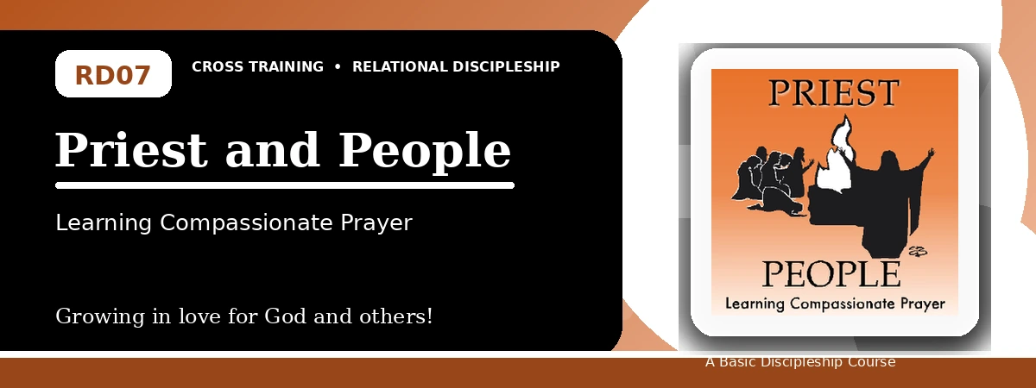
Relational Discipleship: Cross Training
Student Quiz
Receiving Christ's Intercession and Praying for Others
Instructions: Answer the following questions from the lesson. Use Scripture references where helpful. For short answers, write clearly and briefly.

1. [Multiple Choice] What is the lesson's main relationship picture?
A. Priest - People
B. Vine - Branches
C. Teacher - Disciple
D. Master - Servant
________________________________________________________________________________________
2. [Short Answer] What is the basic role of a priest?
________________________________________________________________________________________
________________________________________________________________________________________
3. [Multiple Choice] According to Romans 8:34, what does Christ do for us?
A. Intercedes for us
B. Ignores our weakness
C. Avoids the Father
D. Ends prayer
________________________________________________________________________________________
4. [Fill-in] 1 Peter 2 describes believers as a holy _____.
________________________________________________________________________________________
5. [Scripture Reflection] How does Isaiah 53:12 show Christ's priestly work?
________________________________________________________________________________________
________________________________________________________________________________________
6. [Short Answer] Name the three qualities recommended for interceders.
________________________________________________________________________________________
________________________________________________________________________________________
7. [Multiple Choice] What should a priestly believer do for others?
A. Care and pray for them
B. Avoid their needs
C. Control their choices
D. Boast in personal status
________________________________________________________________________________________
8. [Application] List one need around you that you should pray for.
________________________________________________________________________________________
________________________________________________________________________________________
9. [Memory Verse] What is the memory verse?
________________________________________________________________________________________
10. [Short Answer] Why does relying on Christ make believers more secure?
________________________________________________________________________________________
________________________________________________________________________________________
11. [Discussion] What causes believers to give up on prayer, and how can this lesson encourage them?
________________________________________________________________________________________
________________________________________________________________________________________
12. [Application] What step can you take to develop an evangelism lifestyle?
________________________________________________________________________________________
________________________________________________________________________________________
Optional reflection: What one truth from this lesson should shape your relationships this week?
________________________________________________________________________________________
________________________________________________________________________________________

