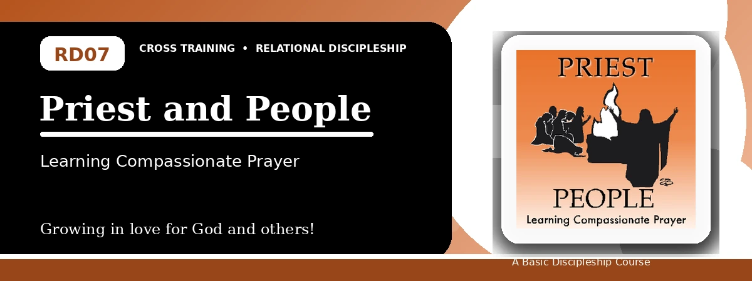
Relational Discipleship: Cross Training
Quiz Answer Key
Receiving Christ's Intercession and Praying for Others
Instructor Use: This answer key gives concise model answers. Accept equivalent answers that clearly reflect the lesson content and Scripture emphasis.

1. [Multiple Choice] What is the lesson's main relationship picture?
A. Priest - People
B. Vine - Branches
C. Teacher - Disciple
D. Master - Servant
Answer: A
2. [Short Answer] What is the basic role of a priest?
Answer: A priest mediates or stands between God and people.
3. [Multiple Choice] According to Romans 8:34, what does Christ do for us?
A. Intercedes for us
B. Ignores our weakness
C. Avoids the Father
D. Ends prayer
Answer: A
4. [Fill-in] 1 Peter 2 describes believers as a holy _____.
Answer: priesthood
5. [Scripture Reflection] How does Isaiah 53:12 show Christ's priestly work?
Answer: It says He bore sin and interceded for transgressors.
6. [Short Answer] Name the three qualities recommended for interceders.
Answer: Be clean, be confident, and be compassionate.
7. [Multiple Choice] What should a priestly believer do for others?
A. Care and pray for them
B. Avoid their needs
C. Control their choices
D. Boast in personal status
Answer: A
8. [Application] List one need around you that you should pray for.
Answer: Answers will vary; should identify a real need.
9. [Memory Verse] What is the memory verse?
Answer: 1 Peter 2:9-10.
10. [Short Answer] Why does relying on Christ make believers more secure?
Answer: Because Christ died, rose, and intercedes for them before God.
11. [Discussion] What causes believers to give up on prayer, and how can this lesson encourage them?
Answer: Answers may mention discouragement, delay, unbelief, or distraction; Christ's intercession encourages perseverance.
12. [Application] What step can you take to develop an evangelism lifestyle?
Answer: Review testimony, practice gospel explanation, pray for opportunity, share with one person, and report back.

Suggested Grading Emphasis
- God showed compassion by sending Christ to die on the cross for us.
- The more we trust Christ, the more secure we become.
- God wants us to represent Him by caring for the needy and praying for them.

