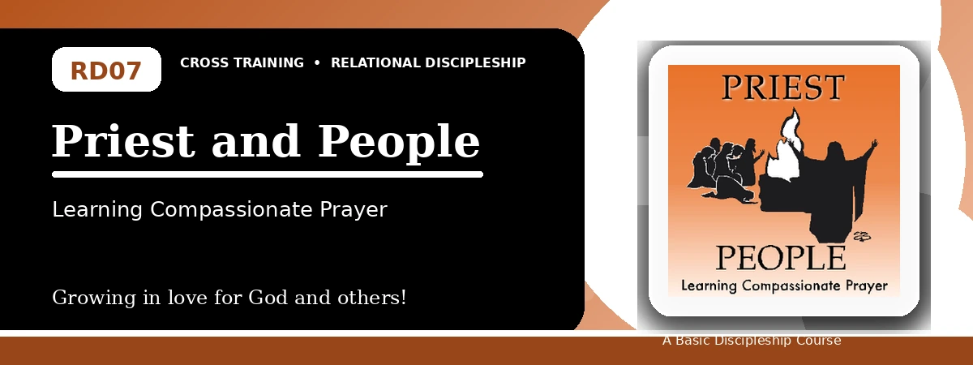
Relational Discipleship: Cross Training
Participant Notes Handout
Receiving Christ's Intercession and Praying for Others
One-line summary: Because Christ is our compassionate Priest, believers learn to rely on Him and intercede for others.
Paragraph summary: The Priest-People lesson explains that a priest stands between God and people. Christ is the perfect Priest who offered Himself for sin and now intercedes for His people. Because believers belong to a holy and royal priesthood, they respond with compassion, confidence, clean hearts, and prayerful attentiveness to the needs around them, representing God through intercession and gospel witness.

Basic Lesson Information
Item | Content
Main relationship picture | Priest - People
Theme | Endurance and Service
Character emphasis | Compassion, other-attentiveness, intercession
Memory verse | 1 Peter 2:9-10

Lesson Goals
- God sent Christ to serve as priest: Learn to have God's compassion
- Christ serves as our priest: Learn how to rely on Christ
- We serve as priests to others: Learn to care and pray for others

Being Compassionate
Key Scripture: Isaiah 53:12; Hebrews 5:8-9; John 3:16
Main ideas:
- Christ bore sin and interceded for transgressors.
- His obedience and suffering show God's compassion.
- God's love in Christ should warm once-cold hearts.
Think about: How does Christ's priestly compassion change your attitude toward others?
Notes:
________________________________________________________________________________________
________________________________________________________________________________________
________________________________________________________________________________________
________________________________________________________________________________________
________________________________________________________________________________________

Relying on Christ
Key Scripture: Numbers 21:7-9; Romans 8:34
Main ideas:
- Christ intervenes and intercedes for His people.
- Those aware of sin should look to God's provision rather than hide.
- Christ's intercession brings security and hope.
Think about: Where do you need to rely on Christ rather than yourself?
Notes:
________________________________________________________________________________________
________________________________________________________________________________________
________________________________________________________________________________________
________________________________________________________________________________________
________________________________________________________________________________________

Caring for Others
Key Scripture: Isaiah 59:16; 1 Peter 2:5; 1 Peter 2:9
Main ideas:
- Believers are a holy and royal priesthood.
- Priestly service includes prayer, clean living, confidence, and compassion.
- Intercession is a practical expression of care.
Think about: Who needs your faithful prayer this week?
Notes:
________________________________________________________________________________________
________________________________________________________________________________________
________________________________________________________________________________________
________________________________________________________________________________________
________________________________________________________________________________________

Take-Home Practice
- Memorize 1 Peter 2:9-10.
- Each day ask God to reveal needs around you.
- Record needs and pray for them one or more times.
- Review your testimony and ask God for an opportunity to share the gospel.

Personal Commitment
This week I will:
________________________________________________________________________________________
________________________________________________________________________________________
________________________________________________________________________________________
________________________________________________________________________________________

