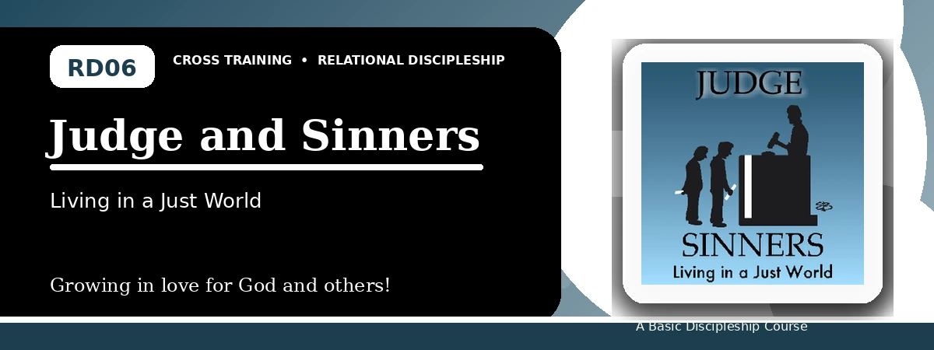
Relational Discipleship: Cross Training
Student Quiz
Receiving Mercy and Showing Mercy Under God's Justice
Instructions: Answer the following questions from the lesson. Use Scripture references where helpful. For short answers, write clearly and briefly.

1. [Multiple Choice] What is the relationship picture for Lesson 6?
A. Judge - Guilty
B. Shepherd - Lamb
C. Husband - Wife
D. Redeemer - Chosen
________________________________________________________________________________________
2. [Short Answer] Why are all sinners guilty before God?
________________________________________________________________________________________
________________________________________________________________________________________
3. [Multiple Choice] What does 1 John 3:5 say Christ appeared to do?
A. Take away sins
B. Avoid judgment
C. Establish a human kingdom
D. Build a physical temple
________________________________________________________________________________________
4. [Fill-in] Luke 6 teaches, "Be merciful, just as your Father is _____."
________________________________________________________________________________________
5. [Scripture Reflection] How should God's final judgment affect the way we view sin?
________________________________________________________________________________________
________________________________________________________________________________________
6. [Short Answer] Name two relationships where the lesson asks us to monitor mercifulness.
________________________________________________________________________________________
________________________________________________________________________________________
7. [Multiple Choice] What should receiving God's mercy produce in us?
A. Mercy toward others
B. Pride over others
C. Excuses for sin
D. Indifference toward the lost
________________________________________________________________________________________
8. [Application] Name one person or group you should pray for because they are lost.
________________________________________________________________________________________
________________________________________________________________________________________
9. [Memory Verse] What is the memory verse?
________________________________________________________________________________________
10. [Short Answer] Why is comparison with others a poor way to measure righteousness?
________________________________________________________________________________________
________________________________________________________________________________________
11. [Discussion] How can mercy be shown without ignoring righteousness?
________________________________________________________________________________________
________________________________________________________________________________________
12. [Application] What merciful action can you take this week?
________________________________________________________________________________________
________________________________________________________________________________________
Optional reflection: What one truth from this lesson should shape your relationships this week?
________________________________________________________________________________________
________________________________________________________________________________________

