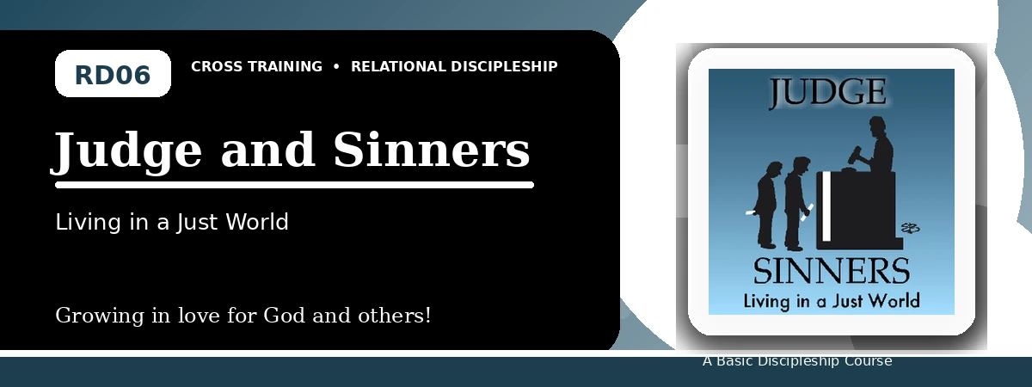
Relational Discipleship: Cross Training
Quiz Answer Key
Receiving Mercy and Showing Mercy Under God's Justice
Instructor Use: This answer key gives concise model answers. Accept equivalent answers that clearly reflect the lesson content and Scripture emphasis.

1. [Multiple Choice] What is the relationship picture for Lesson 6?
A. Judge - Guilty
B. Shepherd - Lamb
C. Husband - Wife
D. Redeemer - Chosen
Answer: A
2. [Short Answer] Why are all sinners guilty before God?
Answer: Because God is perfectly righteous and all human sin violates His standard.
3. [Multiple Choice] What does 1 John 3:5 say Christ appeared to do?
A. Take away sins
B. Avoid judgment
C. Establish a human kingdom
D. Build a physical temple
Answer: A
4. [Fill-in] Luke 6 teaches, "Be merciful, just as your Father is _____."
Answer: merciful
5. [Scripture Reflection] How should God's final judgment affect the way we view sin?
Answer: It should make us take sin seriously, repent, and seek Christ's mercy.
6. [Short Answer] Name two relationships where the lesson asks us to monitor mercifulness.
Answer: Parents, colleagues, neighbors, relatives, enemies, or others.
7. [Multiple Choice] What should receiving God's mercy produce in us?
A. Mercy toward others
B. Pride over others
C. Excuses for sin
D. Indifference toward the lost
Answer: A
8. [Application] Name one person or group you should pray for because they are lost.
Answer: Answers will vary; should identify someone or a group.
9. [Memory Verse] What is the memory verse?
Answer: Luke 6:35-36.
10. [Short Answer] Why is comparison with others a poor way to measure righteousness?
Answer: Because God's standard is His own perfect righteousness, not human comparison.
11. [Discussion] How can mercy be shown without ignoring righteousness?
Answer: By telling truth humbly, forgiving, praying, helping, and pointing people to Christ.
12. [Application] What merciful action can you take this week?
Answer: Answers may include forgiveness, prayer, service, patience, reconciliation, or gospel witness.

Suggested Grading Emphasis
- Because God is wholly righteous, our unrighteousness is apparent.
- God's righteousness demands judgment against sin apart from Christ.
- We must be merciful as our Heavenly Father is merciful to us.

