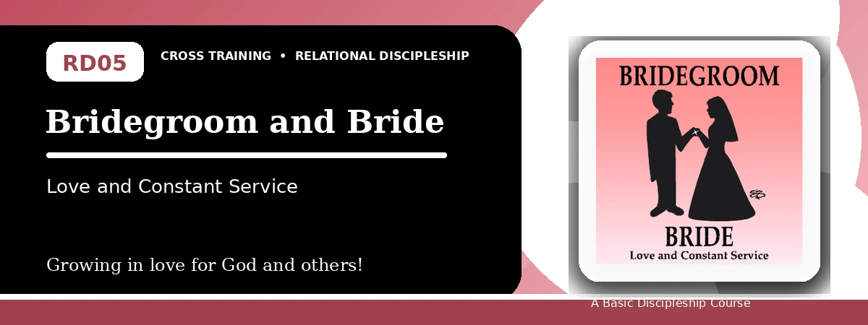
Relational Discipleship: Cross Training
Student Quiz
Remaining Devoted, Ready, and Pure for Christ
Instructions: Answer the following questions from the lesson. Use Scripture references where helpful. For short answers, write clearly and briefly.

1. [Multiple Choice] What relationship picture guides this lesson?
A. Bridegroom - Bride
B. Teacher - Disciple
C. Judge - Guilty
D. Cornerstone - Stones
________________________________________________________________________________________
2. [Short Answer] What did Christ do to secure His bride?
________________________________________________________________________________________
________________________________________________________________________________________
3. [Multiple Choice] What should believers focus on in light of this lesson?
A. Christ's return
B. Personal popularity
C. Avoiding all commitments
D. Worldly success
________________________________________________________________________________________
4. [Fill-in] Revelation 19 says the marriage of the _____ has come.
________________________________________________________________________________________
5. [Scripture Reflection] How does John 14:2-3 encourage believers?
________________________________________________________________________________________
________________________________________________________________________________________
6. [Short Answer] Name two ways to remain devoted to Christ.
________________________________________________________________________________________
________________________________________________________________________________________
7. [Multiple Choice] Which passage warns against being bound together with unbelievers?
A. 2 Corinthians 6:14-18
B. Psalm 23:1
C. 1 Peter 2:5
D. John 15:5
________________________________________________________________________________________
8. [Application] Name one purity standard you should clarify or strengthen.
________________________________________________________________________________________
________________________________________________________________________________________
9. [Memory Verse] What is the memory verse?
________________________________________________________________________________________
10. [Short Answer] Why is readiness more than knowing Christ will return?
________________________________________________________________________________________
________________________________________________________________________________________
11. [Discussion] How does Christ's covenant love shape marriage and singleness?
________________________________________________________________________________________
________________________________________________________________________________________
12. [Application] What would help you delight more in Christ this week?
________________________________________________________________________________________
________________________________________________________________________________________
Optional reflection: What one truth from this lesson should shape your relationships this week?
________________________________________________________________________________________
________________________________________________________________________________________

