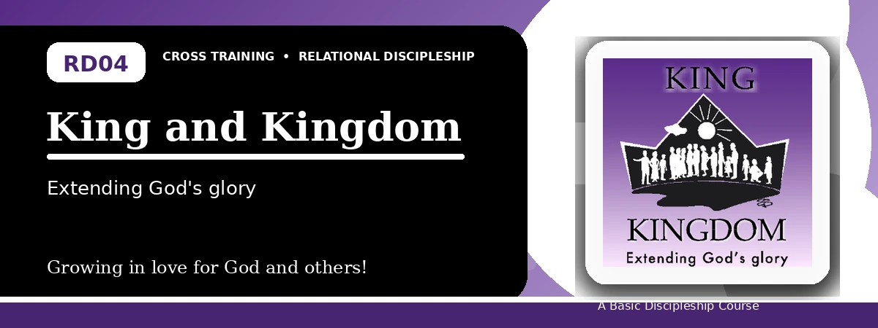
Relational Discipleship: Cross Training
Student Quiz
Living Loyally Under the Rule of King Jesus
Instructions: Answer the following questions from the lesson. Use Scripture references where helpful. For short answers, write clearly and briefly.

1. [Multiple Choice] What is the lesson's main relationship picture?
A. King - Kingdom
B. Shepherd - Lamb
C. Vine - Branches
D. Father - Child
________________________________________________________________________________________
2. [Short Answer] How does a person enter God's kingdom?
________________________________________________________________________________________
________________________________________________________________________________________
3. [Multiple Choice] What does Matthew 6:10 teach kingdom people to pray?
A. Thy kingdom come, Thy will be done
B. Give us a sign
C. Let us rule ourselves
D. Remove all authority
________________________________________________________________________________________
4. [Fill-in] Colossians 1:13 says God transferred us to the kingdom of His beloved _____.
________________________________________________________________________________________
5. [Scripture Reflection] What does it mean to walk in a manner worthy of God's kingdom?
________________________________________________________________________________________
________________________________________________________________________________________
6. [Short Answer] Name two proper responses to King Jesus.
________________________________________________________________________________________
________________________________________________________________________________________
7. [Multiple Choice] Which statement best fits the lesson?
A. Personal preference is secondary to Christ's command
B. The kingdom is only a political nation
C. Christians make their own standards
D. Worship is optional in the kingdom
________________________________________________________________________________________
8. [Application] Write one area where you need to obey the King more fully.
________________________________________________________________________________________
________________________________________________________________________________________
9. [Memory Verse] What is the memory verse?
________________________________________________________________________________________
10. [Short Answer] Why is the kingdom not merely future?
________________________________________________________________________________________
________________________________________________________________________________________
11. [Discussion] How does loyalty to Christ challenge the values of modern culture?
________________________________________________________________________________________
________________________________________________________________________________________
12. [Application] How can your church or small group better show Christ's kingdom?
________________________________________________________________________________________
________________________________________________________________________________________
Optional reflection: What one truth from this lesson should shape your relationships this week?
________________________________________________________________________________________
________________________________________________________________________________________

