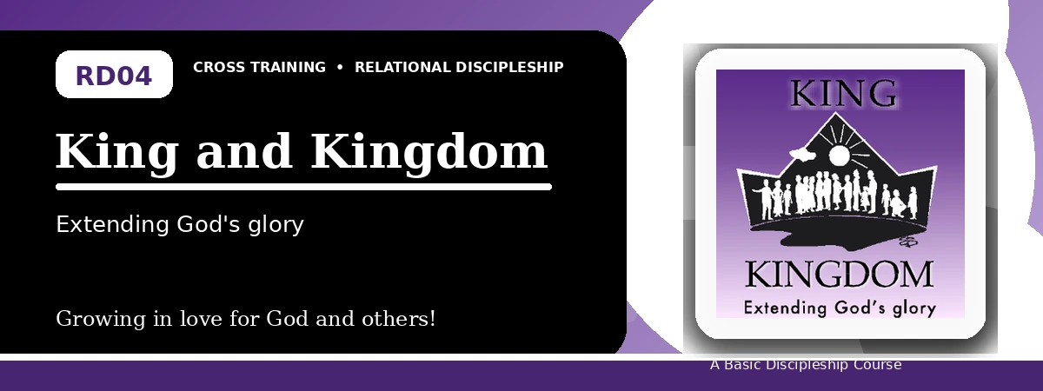
Relational Discipleship: Cross Training
Quiz Answer Key
Living Loyally Under the Rule of King Jesus
Instructor Use: This answer key gives concise model answers. Accept equivalent answers that clearly reflect the lesson content and Scripture emphasis.

1. [Multiple Choice] What is the lesson's main relationship picture?
A. King - Kingdom
B. Shepherd - Lamb
C. Vine - Branches
D. Father - Child
Answer: A
2. [Short Answer] How does a person enter God's kingdom?
Answer: Through faith in the person and work of Christ Jesus.
3. [Multiple Choice] What does Matthew 6:10 teach kingdom people to pray?
A. Thy kingdom come, Thy will be done
B. Give us a sign
C. Let us rule ourselves
D. Remove all authority
Answer: A
4. [Fill-in] Colossians 1:13 says God transferred us to the kingdom of His beloved _____.
Answer: Son
5. [Scripture Reflection] What does it mean to walk in a manner worthy of God's kingdom?
Answer: It means living loyally under God's rule, obeying Christ, and honoring Him in conduct.
6. [Short Answer] Name two proper responses to King Jesus.
Answer: Fear, joy, adoration, obedience, loyalty, worship, and mission.
7. [Multiple Choice] Which statement best fits the lesson?
A. Personal preference is secondary to Christ's command
B. The kingdom is only a political nation
C. Christians make their own standards
D. Worship is optional in the kingdom
Answer: A
8. [Application] Write one area where you need to obey the King more fully.
Answer: Answers will vary; should name a concrete area of obedience.
9. [Memory Verse] What is the memory verse?
Answer: Revelation 17:14.
10. [Short Answer] Why is the kingdom not merely future?
Answer: Because Christ rules His people now, even as the kingdom has a future fullness.
11. [Discussion] How does loyalty to Christ challenge the values of modern culture?
Answer: Answers may mention self-rule, greed, pride, comfort, or independence.
12. [Application] How can your church or small group better show Christ's kingdom?
Answer: By worshiping, obeying Scripture, evangelizing, loving one another, and living under Christ's lordship.

Suggested Grading Emphasis
- Christ is King and Lord, and what He says becomes our standard.
- Christ lived faithfully under His Father's rule, and so should we.
- We respond to King Jesus with fear, joy, adoration, loyalty, and obedience.

