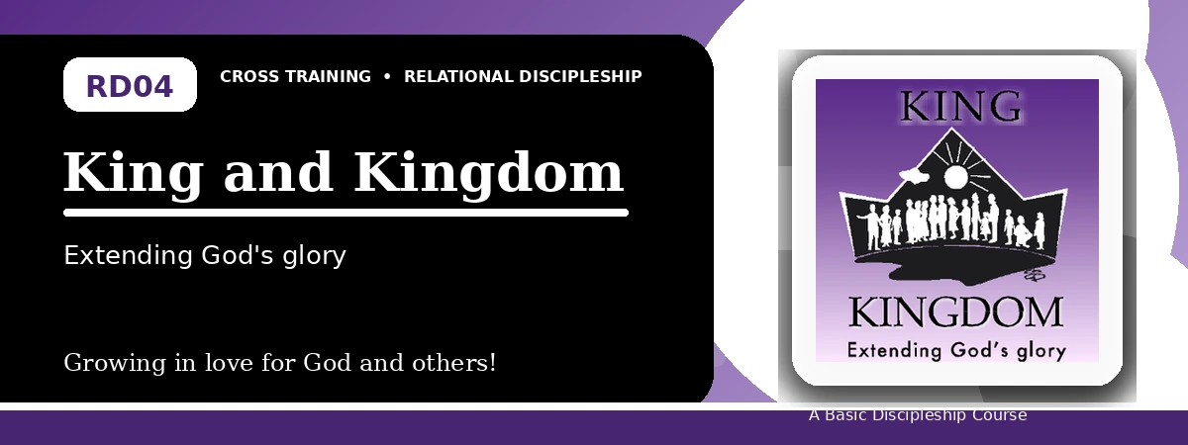
Relational Discipleship: Cross Training
Participant Notes Handout
Living Loyally Under the Rule of King Jesus
One-line summary: Because Christ is King, His people enter His kingdom by faith and live loyally under His commands.
Paragraph summary: The King-Kingdom lesson teaches that Christ rules over a kingdom not of this world. Believers are delivered from darkness into the kingdom of God's beloved Son and now live according to His commands rather than personal preference. As members of His kingdom, Christians join His mission, resist evil, worship with joy and fear, and order their lives around the will of the King.

Basic Lesson Information
Item | Content
Main relationship picture | King - Kingdom
Theme | Obedient and Meek
Character emphasis | Loyalty, obedience, mission, worship
Memory verse | Revelation 17:14

Lesson Goals
- God sent Christ to extend His kingdom: Deliberately join in God's mission
- Christ's kingdom is His people: Purposely live by Christ's commands
- We are princes in Christ's kingdom: Properly respond to King Jesus now

Participate in Christ's Mission
Key Scripture: Mark 10:15; Acts 1:3; Matthew 6:10
Main ideas:
- We enter God's kingdom through faith in Christ, not status, wealth, or nationality.
- The risen Christ taught about the kingdom of God.
- Kingdom people pray for God's will to be done on earth as in heaven.
Think about: How can you deliberately join God's mission this week?
Notes:
________________________________________________________________________________________
________________________________________________________________________________________
________________________________________________________________________________________
________________________________________________________________________________________
________________________________________________________________________________________

Carry Out Christ's Commands
Key Scripture: Colossians 1:13; 1 Thessalonians 2:12; 2 Timothy 4:18
Main ideas:
- Christ's kingdom calls for loyalty of heart.
- Believers walk in a manner worthy of the God who calls them.
- Loyalty to the King continues until the heavenly kingdom.
Think about: Which command of Christ needs your renewed obedience?
Notes:
________________________________________________________________________________________
________________________________________________________________________________________
________________________________________________________________________________________
________________________________________________________________________________________
________________________________________________________________________________________

Respond to King Jesus
Key Scripture: Revelation 17:14; Revelation 1:6
Main ideas:
- Christ is Lord of lords and King of kings.
- His people respond with reverent fear, joy, adoration, and obedience.
- The King's authority becomes the standard for our choices.
Think about: What preference needs to become second to the King's will?
Notes:
________________________________________________________________________________________
________________________________________________________________________________________
________________________________________________________________________________________
________________________________________________________________________________________
________________________________________________________________________________________

Take-Home Practice
- Memorize Revelation 17:14.
- Write your testimony of how you entered God's kingdom.
- Praise the Lord with songs.
- Find or participate in a church where you can worship, evangelize, and hear the Word.

Personal Commitment
This week I will:
________________________________________________________________________________________
________________________________________________________________________________________
________________________________________________________________________________________
________________________________________________________________________________________

