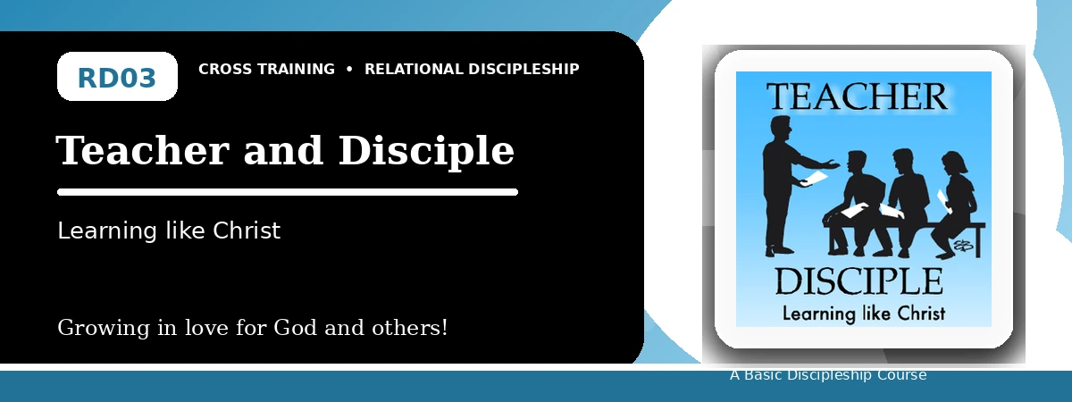
Relational Discipleship: Cross Training
Student Quiz
Learning from Christ and Helping Others Learn Him
Instructions: Answer the following questions from the lesson. Use Scripture references where helpful. For short answers, write clearly and briefly.

1. [Multiple Choice] What is the central relationship picture in this lesson?
A. Teacher - Disciple
B. Redeemer - Chosen
C. Husband - Wife
D. Priest - People
________________________________________________________________________________________
2. [Short Answer] What does Isaiah 50:4 show about Jesus' pattern of learning?
________________________________________________________________________________________
________________________________________________________________________________________
3. [Multiple Choice] What should Christ's disciples do with worldly influence?
A. Replace it with obedience to God's truth
B. Blend it equally with Scripture
C. Ignore all teaching
D. Follow whatever is popular
________________________________________________________________________________________
4. [Fill-in] A fully trained disciple will be like his _____.
________________________________________________________________________________________
5. [Scripture Reflection] How does Matthew 28:18-20 shape the mission of every disciple?
________________________________________________________________________________________
________________________________________________________________________________________
6. [Short Answer] Name the three lesson goals.
________________________________________________________________________________________
________________________________________________________________________________________
7. [Multiple Choice] Which verse describes entrusting truth to faithful people who can teach others also?
A. 2 Timothy 2:2
B. John 10:14
C. Revelation 19:7
D. John 15:5
________________________________________________________________________________________
8. [Application] What one habit can help you become more teachable this week?
________________________________________________________________________________________
________________________________________________________________________________________
9. [Memory Verse] What is the memory verse?
________________________________________________________________________________________
10. [Short Answer] Why must great teachers first be great learners?
________________________________________________________________________________________
________________________________________________________________________________________
11. [Discussion] What makes it difficult to keep following Christ when others withdraw?
________________________________________________________________________________________
________________________________________________________________________________________
12. [Application] Name one person you could encourage, teach, or disciple this month.
________________________________________________________________________________________
________________________________________________________________________________________
Optional reflection: What one truth from this lesson should shape your relationships this week?
________________________________________________________________________________________
________________________________________________________________________________________

