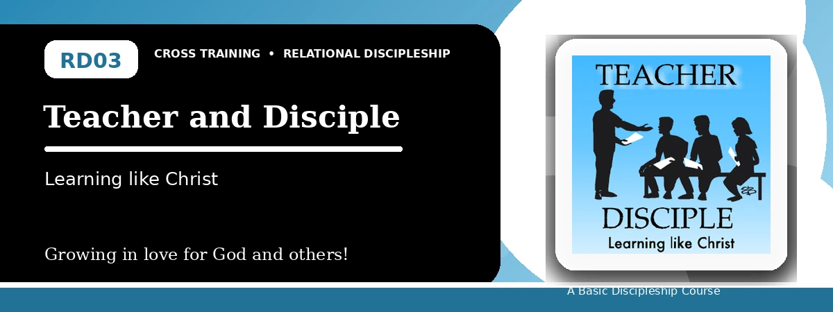
Relational Discipleship: Cross Training
Quiz Answer Key
Learning from Christ and Helping Others Learn Him
Instructor Use: This answer key gives concise model answers. Accept equivalent answers that clearly reflect the lesson content and Scripture emphasis.

1. [Multiple Choice] What is the central relationship picture in this lesson?
A. Teacher - Disciple
B. Redeemer - Chosen
C. Husband - Wife
D. Priest - People
Answer: A
2. [Short Answer] What does Isaiah 50:4 show about Jesus' pattern of learning?
Answer: He listened to the Father morning by morning as a disciple.
3. [Multiple Choice] What should Christ's disciples do with worldly influence?
A. Replace it with obedience to God's truth
B. Blend it equally with Scripture
C. Ignore all teaching
D. Follow whatever is popular
Answer: A
4. [Fill-in] A fully trained disciple will be like his _____.
Answer: teacher
5. [Scripture Reflection] How does Matthew 28:18-20 shape the mission of every disciple?
Answer: It commands disciples to make disciples, baptizing and teaching them to obey Christ.
6. [Short Answer] Name the three lesson goals.
Answer: Listen like Jesus did, follow Christ alone, and make disciples like Jesus.
7. [Multiple Choice] Which verse describes entrusting truth to faithful people who can teach others also?
A. 2 Timothy 2:2
B. John 10:14
C. Revelation 19:7
D. John 15:5
Answer: A
8. [Application] What one habit can help you become more teachable this week?
Answer: Answers may include daily Bible reading, prayer, journaling, asking for correction, or meeting with a mentor.
9. [Memory Verse] What is the memory verse?
Answer: Isaiah 50:4.
10. [Short Answer] Why must great teachers first be great learners?
Answer: Because faithful teaching comes from first listening to and obeying God.
11. [Discussion] What makes it difficult to keep following Christ when others withdraw?
Answer: Answers may mention pressure, fear, comfort, confusion, or lack of commitment.
12. [Application] Name one person you could encourage, teach, or disciple this month.
Answer: Answers will vary; should be specific.

Suggested Grading Emphasis
- When we purposely listen to God day by day, God speaks to us and helps us care for others.
- We follow Christ by replacing the world's influence with obedience to God's truth.
- As people disciple us, we faithfully train others.

