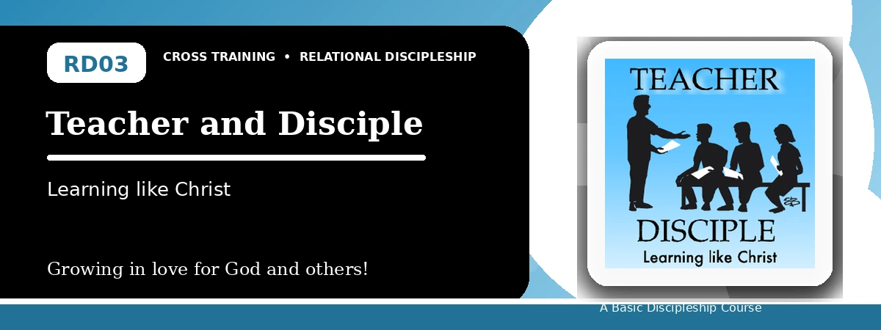
Relational Discipleship: Cross Training
Participant Notes Handout
Learning from Christ and Helping Others Learn Him
One-line summary: Because Christ is the perfect Teacher, His disciples listen, follow, and train others to obey His truth.
Paragraph summary: The Teacher-Disciple lesson calls believers to become teachable followers of Christ. Jesus listened to the Father and taught with authority, showing that great teachers must first be faithful learners. Christians follow Christ alone by replacing worldly influence with His truth, and they participate in His mission by entrusting the gospel to faithful people who can teach others also.

Basic Lesson Information
Item | Content
Main relationship picture | Teacher - Disciple
Theme | Teachable and Wise
Character emphasis | Teachability, wisdom, attentiveness, faithfulness
Memory verse | Isaiah 50:4

Lesson Goals
- Christ learned from the Father: Listen like Jesus did
- Christians are Christ's disciples: Follow Christ alone
- Christians make other disciples: Make disciples like Jesus

Listening Like Christ
Key Scripture: Isaiah 50:4
Main ideas:
- Jesus met with the Father and listened as a disciple.
- The disciple receives a tongue able to sustain the weary with a word.
- Listening to God requires regular discipline, not occasional interest.
Think about: How can your daily schedule make room for listening to God?
Notes:
________________________________________________________________________________________
________________________________________________________________________________________
________________________________________________________________________________________
________________________________________________________________________________________
________________________________________________________________________________________

Walking After Christ
Key Scripture: Mark 2:18; John 14:6; John 6:66-69
Main ideas:
- A disciple is a learner and follower.
- Christ's disciples adopt His perspectives thoroughly.
- True disciples keep following Christ when others turn away.
Think about: Where do you need to replace worldly influence with obedience to Christ?
Notes:
________________________________________________________________________________________
________________________________________________________________________________________
________________________________________________________________________________________
________________________________________________________________________________________
________________________________________________________________________________________

Making Disciples of Christ
Key Scripture: Luke 6:40; 2 Timothy 2:2; Matthew 28:18-20
Main ideas:
- A fully trained disciple becomes like his teacher.
- The gospel is entrusted from one generation of disciples to the next.
- Christ commands His people to make disciples of all nations.
Think about: Who are you helping learn Christ's ways?
Notes:
________________________________________________________________________________________
________________________________________________________________________________________
________________________________________________________________________________________
________________________________________________________________________________________
________________________________________________________________________________________

Take-Home Practice
- Memorize Isaiah 50:4.
- Focus only on Christ and His teaching.
- Make listening to God regular, morning by morning.
- Identify one person you can help grow as a disciple.

Personal Commitment
This week I will:
________________________________________________________________________________________
________________________________________________________________________________________
________________________________________________________________________________________
________________________________________________________________________________________

