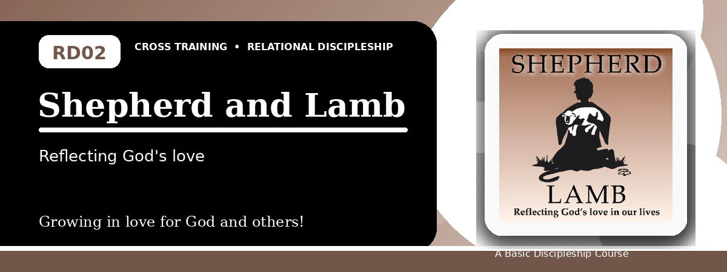
Relational Discipleship: Cross Training
Student Quiz
Trusting the Good Shepherd and Passing on His Care
Instructions: Answer the following questions from the lesson. Use Scripture references where helpful. For short answers, write clearly and briefly.

1. [Multiple Choice] What relationship picture shapes this lesson?
A. King - Kingdom
B. Shepherd - Lamb
C. Judge - Guilty
D. Vine - Branches
________________________________________________________________________________________
2. [Short Answer] According to John 10:14-15, what does the Good Shepherd do for His sheep?
________________________________________________________________________________________
________________________________________________________________________________________
3. [Multiple Choice] What should believers do because God provides a good Shepherd?
A. Rejoice in God's goodness
B. Depend on their own wisdom
C. Avoid needy people
D. Become anxious about the future
________________________________________________________________________________________
4. [Fill-in] Psalm 23 teaches, "The LORD is my shepherd, I shall not _____."
________________________________________________________________________________________
5. [Scripture Reflection] How should Psalm 23:4 help a believer facing fear?
________________________________________________________________________________________
________________________________________________________________________________________
6. [Short Answer] Name two ways Christ shepherds His people.
________________________________________________________________________________________
________________________________________________________________________________________
7. [Multiple Choice] Which passage in the lesson calls believers to love with actions and truth?
A. 1 John 3:17-18
B. Mark 10:15
C. Revelation 1:6
D. 1 Corinthians 4:5
________________________________________________________________________________________
8. [Application] Name one person you can care for this week as a way of passing on the Shepherd's love.
________________________________________________________________________________________
________________________________________________________________________________________
9. [Memory Verse] What is the memory verse for this lesson?
________________________________________________________________________________________
10. [Short Answer] Why is anxiety challenged by the Shepherd-Lamb picture?
________________________________________________________________________________________
________________________________________________________________________________________
11. [Multiple Choice] What does John 10:16 emphasize?
A. Jesus has other sheep to bring
B. Sheep should fear strangers
C. The flock is only one family line
D. Shepherds do not know their sheep
________________________________________________________________________________________
12. [Discussion] How can a church or small group better reflect the Good Shepherd's care?
________________________________________________________________________________________
________________________________________________________________________________________
Optional reflection: What one truth from this lesson should shape your relationships this week?
________________________________________________________________________________________
________________________________________________________________________________________

