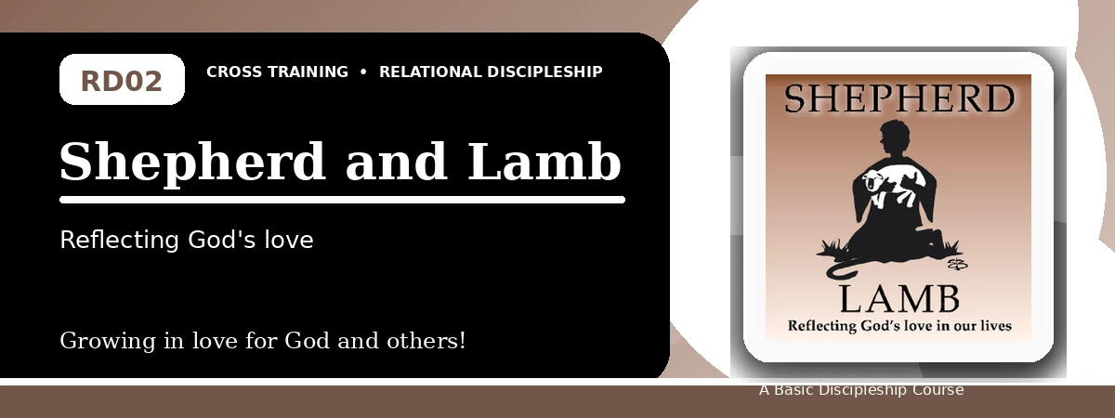
Relational Discipleship: Cross Training
Quiz Answer Key
Trusting the Good Shepherd and Passing on His Care
Instructor Use: This answer key gives concise model answers. Accept equivalent answers that clearly reflect the lesson content and Scripture emphasis.

1. [Multiple Choice] What relationship picture shapes this lesson?
A. King - Kingdom
B. Shepherd - Lamb
C. Judge - Guilty
D. Vine - Branches
Answer: B
2. [Short Answer] According to John 10:14-15, what does the Good Shepherd do for His sheep?
Answer: He knows His sheep and lays down His life for them.
3. [Multiple Choice] What should believers do because God provides a good Shepherd?
A. Rejoice in God's goodness
B. Depend on their own wisdom
C. Avoid needy people
D. Become anxious about the future
Answer: A
4. [Fill-in] Psalm 23 teaches, "The LORD is my shepherd, I shall not _____."
Answer: want
5. [Scripture Reflection] How should Psalm 23:4 help a believer facing fear?
Answer: It reminds the believer that the Shepherd is present, protects, and comforts even in dark valleys.
6. [Short Answer] Name two ways Christ shepherds His people.
Answer: He knows them, provides for them, protects them, and lays down His life for them.
7. [Multiple Choice] Which passage in the lesson calls believers to love with actions and truth?
A. 1 John 3:17-18
B. Mark 10:15
C. Revelation 1:6
D. 1 Corinthians 4:5
Answer: A
8. [Application] Name one person you can care for this week as a way of passing on the Shepherd's love.
Answer: Answers will vary; should identify a person and a concrete act of care.
9. [Memory Verse] What is the memory verse for this lesson?
Answer: John 10:14-15.
10. [Short Answer] Why is anxiety challenged by the Shepherd-Lamb picture?
Answer: Because the Shepherd knows, provides for, and protects His sheep, so they can trust Him.
11. [Multiple Choice] What does John 10:16 emphasize?
A. Jesus has other sheep to bring
B. Sheep should fear strangers
C. The flock is only one family line
D. Shepherds do not know their sheep
Answer: A
12. [Discussion] How can a church or small group better reflect the Good Shepherd's care?
Answer: By noticing needs, praying, protecting the vulnerable, teaching truth, and serving practically.

Suggested Grading Emphasis
- God chooses to care for us.
- Christ knows, provides for, and protects His sheep.
- God wants us to join Him in loving the sheep He has chosen.

