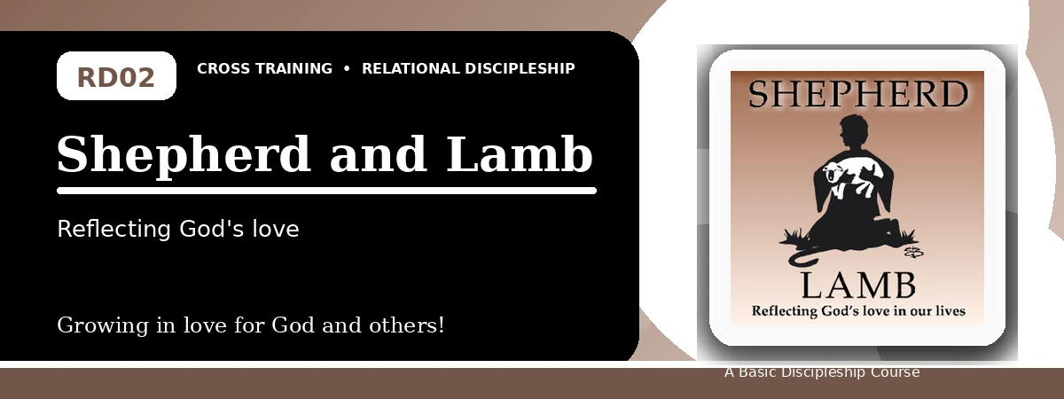
Relational Discipleship: Cross Training
Participant Notes Handout
Trusting the Good Shepherd and Passing on His Care
One-line summary: Because Christ is the Good Shepherd, we can trust His care and learn to extend His love to other needy sheep.
Paragraph summary: The Shepherd-Lamb lesson presents God as the Shepherd who searches for, knows, provides for, and protects His people. Christ is the Good Shepherd who lays down His life for the sheep, and believers respond by trusting Him completely rather than living in fear. Having received His care, Christians learn to notice the needs of others and love in truth and action, becoming channels of the Shepherd's compassion.

Basic Lesson Information
Item | Content
Main relationship picture | Shepherd - Lamb
Theme | Provision and Healing
Character emphasis | Care, trust, peace, compassion
Memory verse | John 10:14-15

Lesson Goals
- God provides a good Shepherd: Rejoice in God's goodness
- Christ is our Shepherd; we are His sheep: Trust God completely
- We are to extend God's love to others: Love others unconditionally

God Provides a Shepherd
Key Scripture: Ezekiel 34:5-11
Main ideas:
- We strayed from God and could not find our way back on our own.
- False shepherds did not truly care for the flock.
- God Himself promised to search for His sheep and seek them out.
Think about: Where have you seen God search you out and care for you?
Notes:
________________________________________________________________________________________
________________________________________________________________________________________
________________________________________________________________________________________
________________________________________________________________________________________
________________________________________________________________________________________

Christ Is Our Shepherd
Key Scripture: John 10:14-15; Psalm 23:1-4
Main ideas:
- Jesus knows His own sheep personally.
- The Shepherd provides what His sheep truly need.
- The Shepherd protects and comforts His sheep, even in dark valleys.
Think about: What fear or anxiety needs to be placed under the Shepherd's care?
Notes:
________________________________________________________________________________________
________________________________________________________________________________________
________________________________________________________________________________________
________________________________________________________________________________________
________________________________________________________________________________________

Extend God's Love
Key Scripture: Ephesians 4:11; 1 John 4:7; John 10:16; 1 John 3:17-18
Main ideas:
- Some lambs are called to shepherd others.
- All believers are called to love others because love comes from God.
- God's love should be shown in truthful words and practical action.
Think about: Who around you needs the Shepherd's care through your life this week?
Notes:
________________________________________________________________________________________
________________________________________________________________________________________
________________________________________________________________________________________
________________________________________________________________________________________
________________________________________________________________________________________

Take-Home Practice
- Memorize John 10:14-15.
- Develop God-attentiveness by journaling ways the Shepherd cares for you.
- Pass on the Shepherd's love to a relative and to a friend through practical care.

Personal Commitment
This week I will:
________________________________________________________________________________________
________________________________________________________________________________________
________________________________________________________________________________________
________________________________________________________________________________________

