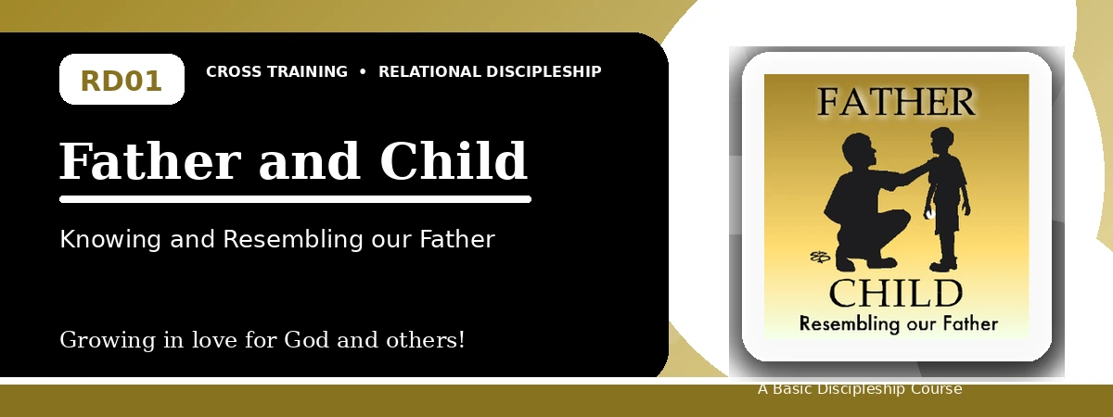
Relational Discipleship: Cross Training
Quiz
Learning to Trust, Obey, and Reflect the Father

Instructions: Answer the following questions from the lesson. Use Scripture references where helpful. For short answers, write clearly and briefly.

1. [Multiple Choice] What is the main relationship picture in Lesson 1?
A. King - Kingdom
B. Father - Son / Father - Child
C. Shepherd - Lamb
D. Priest - People
________________________________________________________________________________________
2. [Short Answer] In one sentence, describe what Jesus models for believers as the Son.
________________________________________________________________________________________
________________________________________________________________________________________
________________________________________________________________________________________
3. [Multiple Choice] According to the lesson, our concepts of God strongly influence what?
A. Our trust in Him
B. Our church schedule
C. Our Bible translation choice
D. Our political opinions
________________________________________________________________________________________
4. [Fill-in] Complete the phrase: The Father loves, provides for, and __________ us.
________________________________________________________________________________________
5. [Scripture Reflection] Matthew 6:8 teaches that the Father knows what we need before we ask. How should that affect prayer?
________________________________________________________________________________________
________________________________________________________________________________________
________________________________________________________________________________________
6. [Multiple Choice] Which verse in the lesson says Jesus came not to do His own will, but the will of the One who sent Him?
A. John 6:38
B. 1 John 3:1
C. Romans 8:28
D. Matthew 5:9
________________________________________________________________________________________
7. [Short Answer] Name the three main responses believers should learn from Jesus toward the Father.
________________________________________________________________________________________
________________________________________________________________________________________
________________________________________________________________________________________
8. [Multiple Choice] Which of the following is one way believers resemble their Father?
A. Winning arguments
B. Making peace
C. Avoiding all difficult people
D. Seeking personal attention
________________________________________________________________________________________
9. [Fill-in] Jesus said, "Blessed are the peacemakers, for they shall be called __________."
________________________________________________________________________________________
10. [Short Answer] Why does the lesson connect loving enemies with being children of the Father?
________________________________________________________________________________________
________________________________________________________________________________________
________________________________________________________________________________________
11. [Application] Identify one practical action a participant could take this week to reflect the Father's love.
________________________________________________________________________________________
________________________________________________________________________________________
________________________________________________________________________________________
12. [Memory Verse] What is the memory verse for this lesson, and what central truth does it emphasize?
________________________________________________________________________________________
________________________________________________________________________________________
________________________________________________________________________________________

Optional reflection: What is one area where you need to trust the Father more this week?
________________________________________________________________________________________
________________________________________________________________________________________
________________________________________________________________________________________

