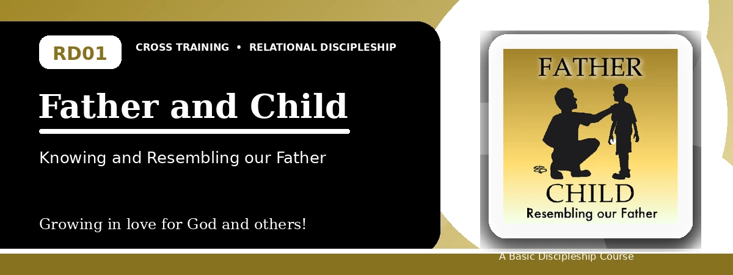
Relational Discipleship: Cross Training
Quiz Answer Key
Learning to Trust, Obey, and Reflect the Father

Instructor Use: This answer key gives concise model answers. Accept equivalent answers when they clearly reflect the lesson content and Scripture emphasis.

1. [Multiple Choice] What is the main relationship picture in Lesson 1?
A. King - Kingdom
B. Father - Son / Father - Child
C. Shepherd - Lamb
D. Priest - People
Answer: B
2. [Short Answer] In one sentence, describe what Jesus models for believers as the Son.
Answer: Jesus models perfect trust, obedience, honor, dependence, and resemblance to His Father.
3. [Multiple Choice] According to the lesson, our concepts of God strongly influence what?
A. Our trust in Him
B. Our church schedule
C. Our Bible translation choice
D. Our political opinions
Answer: A
4. [Fill-in] Complete the phrase: The Father loves, provides for, and __________ us.
Answer: guides
5. [Scripture Reflection] Matthew 6:8 teaches that the Father knows what we need before we ask. How should that affect prayer?
Answer: It should make us pray with trust instead of worry or empty repetition, bringing needs honestly to the Father.
6. [Multiple Choice] Which verse in the lesson says Jesus came not to do His own will, but the will of the One who sent Him?
A. John 6:38
B. 1 John 3:1
C. Romans 8:28
D. Matthew 5:9
Answer: A
7. [Short Answer] Name the three main responses believers should learn from Jesus toward the Father.
Answer: Honor the Father, trust and obey the Father, and depend on the Father.
8. [Multiple Choice] Which of the following is one way believers resemble their Father?
A. Winning arguments
B. Making peace
C. Avoiding all difficult people
D. Seeking personal attention
Answer: B
9. [Fill-in] Jesus said, "Blessed are the peacemakers, for they shall be called __________."
Answer: sons of God
10. [Short Answer] Why does the lesson connect loving enemies with being children of the Father?
Answer: Because the Father shows mercy beyond those who deserve it, and His children should reflect His gracious love.
11. [Application] Identify one practical action a participant could take this week to reflect the Father's love.
Answer: Possible answers include making peace, praying for an enemy, serving another believer, sharing the gospel, or writing needs in a prayer journal.
12. [Memory Verse] What is the memory verse for this lesson, and what central truth does it emphasize?
Answer: 1 John 3:1. It emphasizes the great love of the Father in calling believers children of God.

Suggested Grading Emphasis
- Look for understanding of God as loving Father, not merely correct wording.
- Look for a clear connection between Jesus' example and the believer's response.
- For application answers, reward concrete, biblical actions such as prayer, peace-making, repentance, service, love for enemies, and gospel witness.

