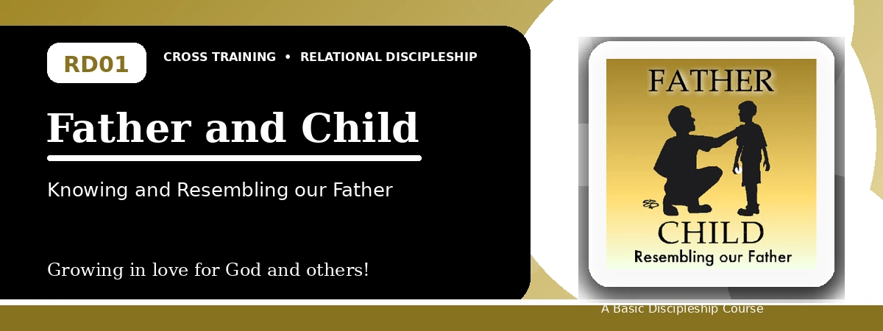
Relational Discipleship: Cross Training
Participant Notes Handout
Learning to Trust, Obey, and Reflect the Father

One-line summary: Because God is our loving Father, we learn from Jesus the Son to trust, obey, depend on Him, and reflect His love to others.
Paragraph summary: This lesson presents Jesus as the perfect Son who trusted, obeyed, honored, and depended on His Father. Since believers are children of God, they are invited to know the Father's love, receive His care, follow His direction, and become like Him in their relationships. The goal is practical discipleship: trusting God rather than worrying, obeying Him when His will is difficult, making peace, loving enemies, caring for fellow believers, and joining the Father's work of bringing others into His family.

Basic Lesson Information
Item | Content
Main relationship picture | Father - Son / Father - Child
Primary character focus | Obedience and loyalty
Core model | Jesus the Son fully trusted, honored, obeyed, and depended on His Father.
Main response | Believers learn to trust the Father, obey Him, and let others see His love through their lives.
Memory verse | 1 John 3:1 - See how great a love the Father has bestowed upon us, that we should be called children of God; and such we are.

Course Invitation
Relational Discipleship helps believers grow by studying the biblical relationship pictures God uses to explain spiritual life. This first session begins with the Father-Son relationship, showing how Jesus trusted His Father and how God's children can learn the same pattern of love, obedience, dependence, and practical care for others. The course is designed for more than information; it trains the heart to respond to God rightly and to reflect His love in everyday relationships.

1. God Is Our Father
Key Scripture: Matthew 3:17; John 16:27; Matthew 6:8; John 6:38
Main ideas:
- The Father loves the Son, and He also loves those who believe in Christ.
- The Father cares for His children and knows their needs before they ask.
- The Father directs and trains His children through His Word, prayer, and circumstances.
Think about: What need, worry, or question should you bring to your Father today?
Notes:
________________________________________________________________________________________
________________________________________________________________________________________
________________________________________________________________________________________
________________________________________________________________________________________
________________________________________________________________________________________
________________________________________________________________________________________

2. Responding to Our Father
Key Scripture: John 12:28; Matthew 5:16; Romans 8:28; Matthew 7:11
Main ideas:
- The Son honors His Father and seeks His glory rather than personal attention.
- The Son trusts and obeys His Father, even when the path is difficult.
- The Son depends on His Father, asking Him for help and provision.
Think about: Where is God asking you to trust and obey rather than worry or control the outcome?
Notes:
________________________________________________________________________________________
________________________________________________________________________________________
________________________________________________________________________________________
________________________________________________________________________________________
________________________________________________________________________________________
________________________________________________________________________________________
________________________________________________________________________________________

3. Resembling Our Father
Key Scripture: Matthew 5:9; Matthew 5:44-45; 1 John 4:7-8; John 17:18
Main ideas:
- Children of God do good works so the Father receives glory.
- Children of God make peace and introduce God's love into strained relationships.
- Children of God love enemies, love fellow believers, and help expand God's family through gospel witness.
Think about: Who should see more of the Father's love through your life this week?
Notes:
________________________________________________________________________________________
________________________________________________________________________________________
________________________________________________________________________________________
________________________________________________________________________________________
________________________________________________________________________________________
________________________________________________________________________________________
________________________________________________________________________________________

Take-Home Practice
- Memorize 1 John 3:1.
- Begin or continue a prayer journal: record needs, dates, requests, and answers.
- Seek peace with your earthly father if there is unresolved sin or bitterness.
- Ask a mature believer how God has cared for them as Father.
- Demonstrate God's love by encouraging or serving another believer.

Personal commitment for this week:
________________________________________________________________________________________
________________________________________________________________________________________
________________________________________________________________________________________
________________________________________________________________________________________

