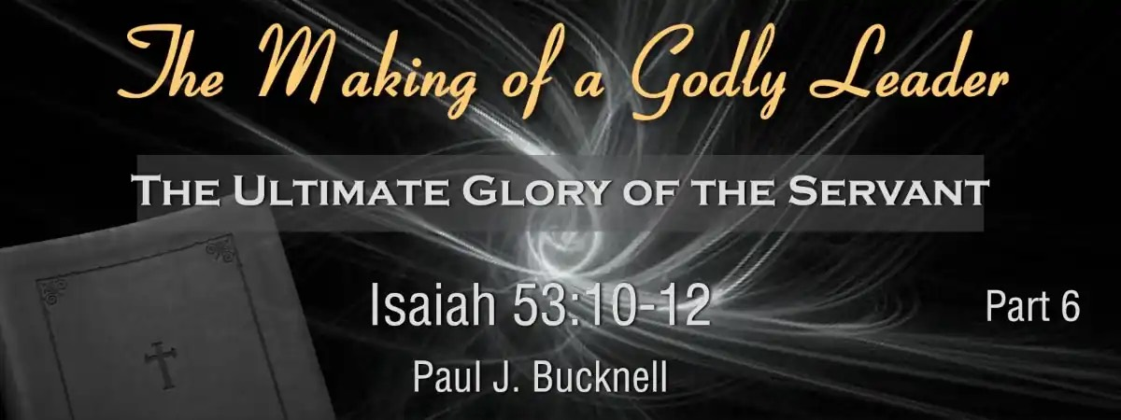

The Making of a Godly Leader
Session #6: Study Notes
Isaiah 53:10-12 The Godly Leader Embraces God’s Ultimate Purposes
This expositional teaching serves as both a theological study and devotional guide, inspiring readers to understand and imitate the Servant’s sacrificial love and leadership while highlighting the redemptive meaning of suffering and the role of the resurrection in Christian theology.

The Five Sections of the Fourth Servant Song
- His Accomplishments: Isaiah 52:13-15
Accepts God’s design for His life
- His Following: Isaiah 53:1-3
Endures God-given hardships
- His Sufferings: Isaiah 53:4-6
Embraces God’s purposes, bears sins
- His Innocent: Isaiah 53:7-9
Endures suffering, remains innocent
- His Purpose: Isaiah 53:10-12
Embraces God’s ultimate purpose

The Major Themes (Isaiah 53:10-12)
- God’s Pleasure in the Servant’s Sacrifice for Redemption: This is evident from Isaiah 53:10, where the Lord was pleased to crush Him, making Him a guilt offering, in accordance with God’s good will and His redemptive purpose.
- The Effectiveness of the Servant's Sacrifice in Justifying: The Servant’s anguish in Isaiah 53:11 leads to the satisfaction and justification of many, emphasizing its salvific impact, as described in the “Effective Sacrifice” section.
- The Rewards and Blessings the Servant Receives Post-Sacrifice: From Isaiah 53:12, the Servant is assigned a portion with the great, shares the spoils, and intercedes, indicating his ultimate glory, as discussed under “Blessings from His Death.”

Contemplating the “U” Pattern
The “U” pattern provides a narrative arc of descent (suffering) followed by ascent (glory), offering a structural lens for understanding the Servant’s journey in His life as described in Isaiah 53.
This teaching is best illustrated by a “U” structure, which provides a pattern of descent followed by ascent. The three pursuits for a godly leader (rise up, be lifted up, be exalted on high) and practical applications, such as suffering as a strategy and fixing our eyes on Jesus, reinforce the themes of glory following suffering.

Fill-in-the-Blank Questions for Isaiah 53:10-12
Below are 10 questions with blanks for you to fill in based on the slide’s content.
- “But the Lord was pleased to ______ Him, putting Him to ______.”
- “If He would render Himself as a ______ offering.”
- “He will see His ______.”
- “He will prolong His ______.”
- “As a result of the ______ of His soul, He will see it and be satisfied.”
- The Servant’s suffering was not a(n) ________ but a part of God’s plan.
- “He will see His offspring” as referring to His ________.
- The phrase “He will prolong His days” is linked to the Servant’s ________ and ________ life.
- Suffering is a ________ part of serving God.
- The servant’s journey follows a 'U' pattern of ________ followed by ________.

A reflective question
Explain how Jesus’ suffering and death brought such change.
Answers: crush + grief; guilt, offspring, days, anguish, accident; spiritual offspring or believers; resurrection + eternal; strategic; descent + ascent

