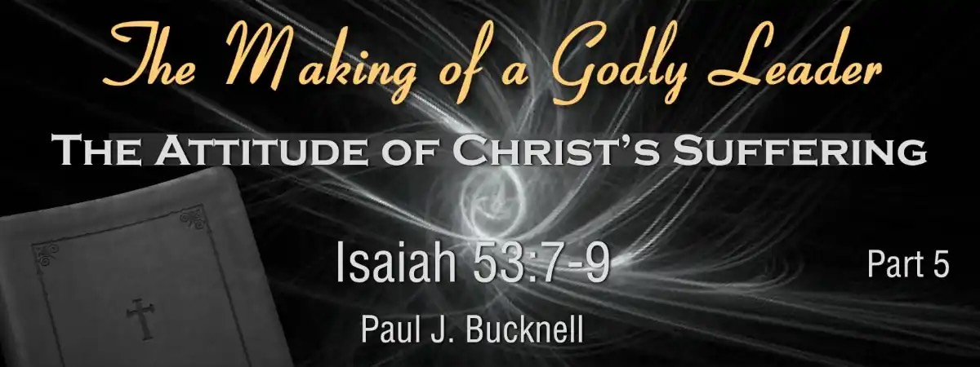

The Making of a Godly Leader
Session #5: Study Notes
The Godly Leader Endures Through Hardship
This expositional teaching helps us understand the Servant’s attitude toward injustice, God’s will, and suffering—an attitude we desperately need to embrace.

The Five Sections of the Fourth Servant Song
- His Accomplishments: Isaiah 52:13-15
Accepts God’s design for His life
- His Following: Isaiah 53:1-3
Endures God-given hardships
- His Sufferings: Isaiah 53:4-6
Embraces God’s purposes, bear sins
- His Innocent Isaiah 53:7-9
Endures suffering, remains innocent
- His Purpose: Isaiah 53:10-12
Embraces God’s ultimate purpose

The Major Themes (Isaiah 53:7-9)
- Christ’s willingness to suffer silently: It is clear from Isaiah 53:7 that He did not open His mouth, likened to a lamb led to slaughter, and this is further supported by His determined journey to Jerusalem (Luke 9:51) and His act of trusting Himself to God (1 Peter 2:23).
- The unjust and terrible nature of His suffering: From Isaiah 53:8, His suffering resulted from oppression and judgment, being cut off from the living for the transgressions of others, which emphasizes its unfair and severe nature.
- His innocence and sinlessness: From Isaiah 53:9, He had done no violence or deceit, and though He was assigned a grave with the wicked, He was buried with a rich man, underscoring His purity.

A Prophetic Insight
Isaiah 53 highlights twenty prophetic statements depicting Christ as the Servant, such as “like a sheep...silent before its shearers” and “numbered with the transgressors.” These statements affirm Christ’s identification.

Fill-in-the-Blank Questions for Isaiah 53:7-9
Below are 10 questions with blanks for you to fill in based on the slide’s content.
- Isaiah 53:7 He was ________ and He was ________, yet He did not open His mouth.
- Jesus displayed an attitude of ______ by remaining silent during His suffering.
- Isaiah 53:8 By ________ and ________ He was taken away.
- The prophecy in Isaiah 53 highlights the concept of ______: Jesus taking the punishment meant for others.
- Isaiah 53:8 for the ________ of my people to whom the stroke was due?
- Isaiah 53:9 His grave was assigned with ________ men.
- Jesus suffered not because He was evil but because of ______.
- Isaiah 53:9 because He had done no ________, nor was there any ________ in His mouth.
- Isaiah 53 teaches that God uses suffering for a greater ______ in His divine plan.
- The 20 prophetic statements in Isaiah 53 include “He will justify the ______” (Isaiah 53:11).

Answers: oppressed + afflicted; humility; oppression + judgment; substitutionary atonement, transgression, wicked, substitution (His redemptive work); violence + deceit; purpose; many

