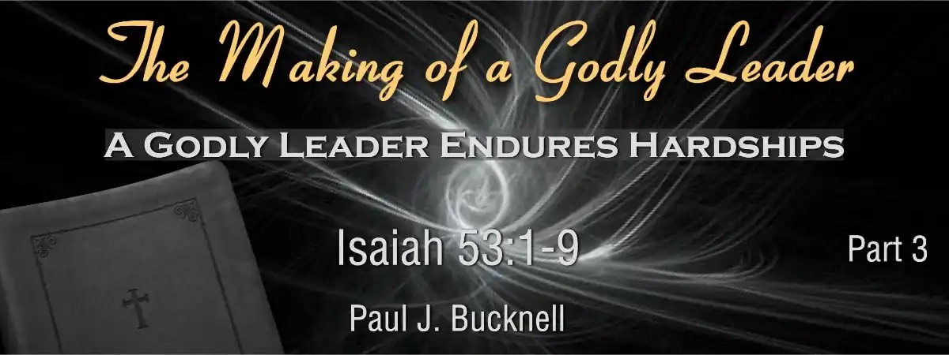

The Making of a Godly Leader
Session #3: Study Notes on Isaiah 53:1-3
The Difficulty of Christ’s Life, Isaiah 53:1-3, includes three verses that reveal the severity of the Servant’s sufferings, specifically His rejected message, personal feelings of inadequacy, and societal rejection. The godly leader must rise above these challenges to be an effective servant of the Lord.

The Five Sections of the Fourth Servant Song
- His Accomplishments: Isaiah 52:13-15
Accepts God’s design for His life
- His Following: Isaiah 53:1-3
Endures God-given hardships
- His Sufferings: Isaiah 53:4-6
Embraces God’s purposes, bear sins
- His Innocent: Isaiah 53:7-9
Endures suffering, remains innocent
- His Purpose: Isaiah 53:10-12
Embraces God’s ultimate purpose

The Difficulty of Christ’s Life (Isaiah 53:1-3)
- Christ’s message doubted - Isaiah 53:1
Few believed, the arm of Lord revealed
- Christ personally avoided - Isaiah 53:2
No stately form, not attractive
- Christ socially rejected - Isaiah 53:3
Despised, forsaken, not esteemed

Fill-in-the-Blank Questions for Session 3
Below are 10 questions with blanks for you to fill in based on the slide’s content.
- The godly leader must endure through ________.
- The Path of God’s Servant’s “His Following” is based on Isaiah ________:_______.
- In Isaiah 53:1, the question “Who has believed our message?” indicates that Christ’s message was ________ by many.
- The arm of the Lord in Isaiah 53:1 refers to God’s ________.
- Jesus did not entrust Himself to them, showing He did not need their ________ to fulfill His mission.
- Many disciples withdrew from Jesus after hearing His teachings, illustrating that His message was often ________.
- People questioned if any good thing could come from ________.
- For a successful ministry, only the Holy Spirit’s ________ and a persevering ________ are needed.
- Paul considered all things as ________ compared to knowing Christ.
- The servant is described as a tender shoot in parched ground, symbolizing his ________ beginnings.

Answers: hardship, 53:1-3, doubted, power, approval, rejected, Nazareth, anointing and spirit, rubbish, humble

